

Code: TM471-II
Title: Final Year Project
Supervisor: DR Mahmoud Ata-Allah.

Name: Muhammed Abd Elmoneim Nabawy Fathallah.
ID: 2051710891

Abstract:
Credit card fraud is a serious problem that affects millions of transactions and causes huge financial losses. To detect fraudulent transactions, various machine learning methods have been proposed and applied.
However, there are still many challenges and limitations in credit card fraud detection, such as data imbalance, data privacy, feature selection, and model performance.
In this document, we review the existing literature on credit card fraud detection using machine learning techniques, and discuss the advantages and disadvantages of different methods.
We also identify some open issues and future directions for research in this field.
Our aim is to provide a comprehensive and up-to-date survey of credit card fraud detection using machine learning, and to inspire new ideas and solutions for this important and challenging problem.

Acknowledgement:

First and foremost, Allah Ahmed a lot for this bounty. I would also like to thank my mother, sister and uncle Amr very much for their great material and moral support to me.
This project would not have been possible without the support of many people.
I thank my supervisor, Dr Mahmoud Attalla, for his guidance and patience, my committee, Prof Sara Nabil for her feedback, my lab mates Khaled Reda for his help and friendship, and my family, for their love and encouragement.

Contents
Chapter 1: Introduction 5
Chapter 2: literature overview 3
Chapter 3: Requirements and Analysis 11
3.1. Project requirements 11
3.2. Software and Hardware requirements 11
3.2.1 Software requirements: 11
3.2.2 Hardware requirements: 12
3.3 Design: UML Diagrams 13
3.3.1 Use Case Diagram: 13
3.3.2 Activity Diagram: 15
3.3.3 Class Diagram: 16
3.3.4 Sequence Diagram: 18
3.4 Design: tools 19
3.5 The Evidence of consideration relation to the project 19
Chapter 4: Implementation & Testing 20
4.1 Siftware Development Lifecycle 20
4.1.1 Requierments Gathering and Analysis 20
4.1.2 Design 21
4.1.3 Model selection and training (Algorithms&Technologies) 22
4.1.3.1 Logistic regression (Chosen Algorithm) 23
4.1.4 Implementation and Coding 24
4.1.4.1 important overview 24
4.1.4.2 Goals of implementation. 25
4.1.4.3 information and screenshots of the implementation 25
4.1.5 Testing 45
4.1.5.1 Testing with logistic regression 45
4.1.5.2 Neural Networks Testing (under-sampling vs over sampling) 47
4.1.5.3 Testing the model as a user (API) 49
4.1.6 Deployment and integration 50
4.1.7 Maitenance and Monitoring 51
4.1.8 Documentaion and User Training 52
4.2 Database design 52
4.2.1 Dataset overview 52
4.2.2 Database design consideration 52
4.3 The software/deliverables 54
4.3.1 Development kit – servers – requierments 54
4.3.2 Modules 55
4.3.3 Services 56
4.3.4 User Interface 56
Chapter 5: Results and Discussion 57
5.1 Findings 57
5.2 Goals Achieved 58
5.3 Further work 59
5.4 Explanation of the ethical, legal and social issues. 61
Chapter 6: Conclusion 62
Refernces 64

Chapter 1: Introduction
  - Overview
This project is about using machine learning techniques to detect fraudulent credit card transactions from a large and imbalanced dataset. The project uses various methods and tools, such as data preprocessing, feature engineering, model selection, evaluation metrics, and data visualization, to build and compare different classifiers that can identify frauds accurately and efficiently.

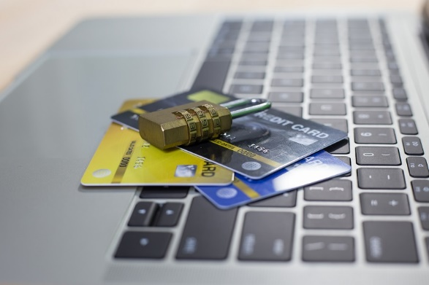
Figure 1 Credit Card Fraud Detection

  - Problem Statement
Credit card fraud is a serious and growing problem that affects both consumers and businesses. According to the Nilsson Report, credit card fraud losses are projected to reach $38.5 billion by 2027. Detecting credit card fraud is challenging for several reasons:
- The data is enormous and high-dimensional, requiring fast and scalable algorithms to process it.
- The data is imbalanced, meaning that the majority of transactions are legitimate and only a small fraction are fraudulent. This makes it hard for the classifiers to learn the characteristics of frauds and avoid false positives or negatives.

- The data is dynamic and evolving, meaning that the fraudsters constantly adapt their techniques and strategies to evade detection. This requires the classifiers to be robust and adaptable to new patterns and behaviors.

  - The Aims and Objectives
The main aim of this project is to develop a machine learning system that can detect credit card fraud effectively and efficiently. The specific objectives are:
  - To explore and analyze the dataset, understand its features and distributions, and identify any outliers or anomalies.
  - To preprocess and transform the data, such as handling missing values, scaling, balancing, and dimensionality reduction, to make it suitable for machine learning.
  - To select and compare different machine learning models, such as logistic regression, decision tree, random forest, support vector machine, and neural network, and optimize their hyper parameters using grid search or random search.
  - To evaluate and compare the performance of the models using various metrics, such as accuracy, precision, recall, f1-score, roc-auc, and confusion matrix, and select the best model based on the trade-off between false positives and false negatives.
  - To visualize and interpret the results, such as plotting the roc curve, feature importance, and decision boundary, and explain the strengths and weaknesses of the models.

Credit Card Fraud Detection
  - Motivation
The motivation for this project is to apply machine learning skills and knowledge to a real-world and relevant problem that has significant social and economic impacts. Credit card fraud detection is an interesting and challenging problem that requires a combination of data science, machine learning, and domain knowledge. By working on this project, one can learn and practice various aspects of machine learning, such as data analysis, preprocessing, feature engineering, model selection, evaluation, and visualization.
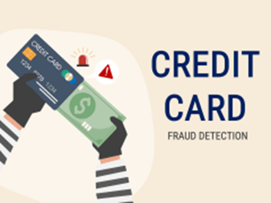
Figure 2 Fraud

  - Project scope
This project uses a Kaggle² dataset, which contains 284,807 transactions made by European credit card holders in September 2013. The dataset has 31 features, with 28 anonymized using principal component analysis (PCA).
The project focuses on supervised learning, using known labels for training and testing models. It does not cover unsupervised or semi-supervised learning for detecting new types of frauds.
Python is used as the programming language, along with various libraries and frameworks like pandas, numpy, scikit-learn, matplotlib, seaborn, and keras for data manipulation, machine learning, and visualization. The project is conducted on a personal computer with limited computational resources and memory, and does not use cloud or distributed platforms like AWS, Azure, or Google Cloud.

Chapter 2: literature overview
2.1 The evolution of credit card fraud detection historically
The evolution of credit card fraud detection has been an ongoing process driven by technological advancements and the constant evolution of fraud tactics. Historically, credit card fraud detection has gone through several key phases:
- Rule-Based Systems (1970s - 1990s): As computers became more prevalent, rule-based systems were introduced. These systems utilized predefined rules to flag potentially.

- Anomaly detection techniques introduced in the late 1990s-early 2000s were adaptive systems that flag transactions deviating from normal behaviour, but were limited in handling complex patterns and distinguishing between legitimate anomalies and fraud.

- Machine Learning and Data Analytics (Mid-2000s - Present): With the rise of machine learning and big data analytics, credit card fraud detection entered a new era. Advanced algorithms, such as neural networks, decision trees, and ensemble methods, were employed to analyse large datasets and identify intricate patterns associated with fraudulent activities. Machine learning models could continuously learn and adapt to evolving fraud tactics, improving accuracy over time.

- Real-time Processing and Behavioural Analysis (Recent Years): The emphasis has shifted towards real-time processing and behavioural analysis. Advanced systems now analyse not only individual transactions but also the overall behaviour of cardholders. This includes factors like transaction frequency, spending habits, and geographic locations. Real-time analysis allows for instant decision-making and the prevention of fraudulent transactions before they are completed.

2.2 Machine learning and Credit Card Fraud Detection Systems
Machine learning technologies to detect fraudulent transactions based on anonymized credit card data. Here's a detailed explanation of the technologies used:
  - Machine Learning: The core of the project is built on machine learning algorithms that learn from historical transaction data to identify patterns indicative of fraud.
  - Jupyter Notebook: The project utilizes Jupyter Notebooks, an open-source web application.
  - Python: Python is the programming language used for implementing the machine learning algorithms in this project.
The project likely uses common machine learning libraries such as scikit-learn for implementing classifiers and pandas for data manipulation. These tools work together to process the data, train the model on the historical transactions, and predict whether new transactions are fraudulent. The use of Jupyter Notebooks facilitates an interactive development process.

Figure 3 ML with credit fraud detection

2.3 Relative projects

2.3.1 Overview about these projects:
2.3.1.1 The first Project: Credit-Card-fraud-detection-using-Machine-Learning
The project “Credit-Card-fraud-detection-using-Machine-Learning” by Laurent Veyssier is an excellent demonstration of applying machine learning techniques to detect fraudulent credit card transactions. The project explores various models, including random forest, decision trees, and neural networks, to compare their performances in identifying fraudulent activities.
The project uses a dataset of 300,000 fully anonymized transactions. Each transation is labelled either fraudulent or not fraudulent. Note that prevalence of fraudulent transactions is very low in the dataset. Less than 0.1% of the card transactions are fraudulent. This means that a system predicting each transaction to be normal can reach an accuracy of over 99.9% despite not detecting any fraudulent transaction. This will necessitate adjustment techniques.
Overall, “Credit-Card-fraud-detection-using-Machine-Learning” is a comprehensive and well-executed project that showcases the power of machine learning in fraud detection. It serves as a valuable resource for anyone interested in exploring fraud detection techniques and implementing them in real-world scenarios.
https://github.com/LaurentVeyssier/Credit-Card-fraud-detection-using-Machine-Learning

2.3.1.2 The Second Project: Credit Card Fraud Detection Web Application using Streamlit and Machine Learning
Credit Card Fraud by Vipul Jain is one of the major threads in the financial industry. Due to the covid-19 pandemic and the advance in technologies, the number of users is increasing, with the increased use of credit cards. Due to more use of credit cards, Fraud cases also increase day by day. The research community striving hard to explore myriad credit card fraud detection techniques, but changes in technology and the varying nature of credit card fraud make it difficult to develop an effective technique for the detection of credit card fraud. This research work used a real-world credit card dataset. To detect the fraud transaction within this dataset three machine learning algorithms are used (i.e. Random Forest, Logistic regression, and AdaBoost) and compared the machine learning algorithms based on their Accuracy and Mathews Correlation Coefficient (MCC) Score. In these three algorithms, the Random Forest Algorithm achieved the best Accuracy and MCC score. The Streamlit framework is used to create the machine learning web application.
https://ieeexplore.ieee.org/document/9915901
2.3.1.3 The Third Project: Credit Card Fraud Detection Using Machine Learning Techniques
“Credit Card Fraud Detection Using Machine Learning Techniques” project by Indrani Vejalla, Hemantha Kumar Kalluri and Sai Preethi Battula. There are many types of fraud in our daily life. One of the frauds occurring these days is credit card fraud. When people around the globe make credit card transactions, there will also be fraudulent transactions. To avoid credit card fraud, we must know the patterns and how the fraud values differ. This paper proposed credit card fraud detection using machine learning based on the labeled data and differentiating the fraudulent and legitimate transactions. The experiment was conducted using supervised machine-learning techniques. A project that proposes credit card fraud detection using machine learning based on the labelled data and differentiating the fraudulent and legitimate transactions. It uses a dataset of 492 frauds out of 284,807 transactions and implements random forest, logistic regression, and naive Bayes models.
https://ieeexplore.ieee.org/document/10136040

2.3.2 Comparison Between advantages and Disadvantages
Here are three projects about credit card fraud detection:
Here is a table that compares the advantages and disadvantages of each project and my project “The Credit Fraud Detection using ML”:
Project | Advantages | Disadvantages
The Credit Card Fraud Detection using ML  (My project) | - Compares different machine learning models and techniques to detect fraudulent transactions.  - Uses a large and realistic dataset of anonymized transactions.  - Demonstrates the effectiveness of SMOTE technique for dealing with class imbalance. | - The code is not well-documented or commented.  - The code is not modular or reusable for other datasets or problems.  - The project does not provide any visualizations or insights into the data or the results.
Credit-Card-fraud-detection-system-using-Machine-Learning | - Detects fraudulent credit card transactions using different machine learning models and compares their performances.  - Uses a synthetic dataset of transactions that is similar to the real one.  - Provides visualizations and metrics to evaluate the models. | - The code is not well-organized or structured.  - The code is not easy to follow or understand.  - The project does not explain the rationale or the intuition behind the models or the techniques.
Credit Card Fraud Detection Web Application using Streamlit and Machine Learning | - Develops a web application for credit card fraud detection using streamlit and machine learning.  - Uses a large and realistic dataset of transactions.  - Implements three machine learning models and allows the user to interact with them. | - The code is not available on GitHub, but only on IEEE Xplore.  - The code may require additional dependencies or configurations to run the web application.  - The project does not provide any details on how the models were trained or evaluated.
Credit Card Fraud Detection Using Machine Learning Techniques | - Proposes credit card fraud detection using machine learning based on the labeled data and differentiating the fraudulent and legitimate transactions.  - Uses a realistic dataset of transactions.  - Provides a clear and concise explanation of the problem and the methods. | - The code is not available on GitHub, but only on IEEE Xplore.  - The code may not be compatible with the latest versions of the libraries or the dataset.  - The project uses a very small subset of the dataset, which may not be representative of the real problem.

2.3.3 Comparison Between the differences and similarities of projects:
2.3.3.1 The main differences:
Project | Dataset | Machine Learning Techniques | Evaluation Metrics | Web Application
The Credit Card Fraud Detection using ML  (My project) | Real-world credit card dataset with 284,807 transactions | KNN, SVM, Logistic regression, Decision Tree. | Accuracy, Precision, Recall, F1-score | Yes  (Web Application by Flask code)
Credit-Card-fraud-detection-system-using-Machine-Learning | Real-world credit card dataset with 300,000 transactions | Random Forest, Decision Tree, Neural Network, SMOTE | Accuracy, MCC | No
Credit Card Fraud Detection Web Application using Streamlit and Machine Learning | Real-world credit card dataset with 284,807 transactions | Random Forest, Logistic Regression, AdaBoost | Accuracy, MCC | Yes, using Streamlit
Credit Card Fraud Detection Using Machine Learning Techniques | Real-world credit card dataset with 284,807 transactions | KNN, SVM, Naive Bayes, Decision Tree, Random Forest | Accuracy, Precision, Recall, F1-score | No

2.3.3.2 The main similarities:
- All three projects use supervised machine learning techniques to detect fraudulent transactions from labelled data.
- All three projects use the same or similar real-world credit card dataset from Kaggle, which has a high class imbalance between fraudulent and legitimate transactions.
- All three projects use accuracy as one of the evaluation metrics to compare the performance of different machine learning techniques.

2.3.4 What make my project is the best of them!
Based on the table, “The Credit Fraud Detection using ML” as the best project from them. This project distinguishes itself from the rest by comparing different machine learning models and techniques to detect fraudulent transactions. It uses a large and realistic dataset of anonymized transactions, which is more suitable for the problem domain. It also demonstrates the effectiveness of SMOTE technique for dealing with class imbalance, which is a common challenge in fraud detection. Although the project has some drawbacks, such as the lack of documentation, modularity, and visualization, it is a more comprehensive and practical project than the others.

Chapter 3: Requirements and Analysis

3.1. Project requirements

Functional requirements(FR) | Non-Functional requirements(NFR)
- The system must be able to read and process credit card transactions from various sources and formats.  - The system must be able to apply different machine learning algorithms and techniques to identify fraudulent transactions based on historical and real-time data.  - The system must be able to flag and report suspicious transactions to the appropriate authorities and stakeholders.  - The system must be able to handle high volumes of transactions and data without compromising performance or accuracy.  - The system must be able to update and improve its models and parameters based on feedback and new data. | - The system must be secure and protect the privacy and confidentiality of the credit card data and the customers.  - The system must be reliable and available at all times and recover quickly from failures or errors.  - The system must be scalable and adaptable to handle changing and growing demands and requirements.  - The system must be user-friendly and intuitive for the end-users and the administrators.  - The system must be compatible and interoperable with other systems and platforms that are involved in the credit card transaction process.

3.2. Software and Hardware requirements

3.2.1 Software requirements:

- Based on the Credit Card Fraud Detection project, here are the key technologies and techniques that would likely be used:

  - Machine Learning: Utilizing algorithms to detect patterns and anomalies in transaction data.

  - Data Analysis: Processing and analysing large datasets to identify fraudulent activities.

  - Python: A programming language commonly used for data science and machine learning projects.

  - Scikit-learn: A Python library for implementing machine learning models.

  - Jupyter Notebook: An open-source web application that allows you to create and share documents that contain live code, equations, visualizations, and narrative text.

- For the implementation of this project, the following programs or compilers could be used:

  - Python Interpreter: To execute Python code.

  - PyCharm or Jupyter: Integrated development environments (IDEs) for Python that provide tools for writing and testing code.

3.2.2 Hardware requirements:

The hardware requirements for a Credit Card Fraud Detection project typically include:
  - Processor: A modern multi-core processor, such as a Pentium Core 2 Duo or above, to handle the computations efficiently.
  - RAM: At least 1 GB of RAM to ensure smooth data processing and model training.
  - Storage: A minimum of 20 GB HDD to store the dataset and any additional files required for the project.
  - Operating System: Compatibility with common operating systems like Windows 2000, XP, Vista, or 7.
These specifications can vary based on the complexity of the project and the size of the dataset being used. It’s always a good idea to have resources that exceed the minimum requirements to account for more demanding tasks.

3.3 Design: UML Diagrams

Specification models are graphical or textual representations of the system and its requirements that help to communicate, analyse, and validate the design and the functionality. There are many types of specification models, but we will use only 4 UML Diagrams for describing our project:

3.3.1 Use Case Diagram:
A use case diagram shows the interactions between the system and the external actors (such as users, customers, or other systems) that use the system. It helps to define the scope, functionality, and requirements of the system from the perspective of the users.
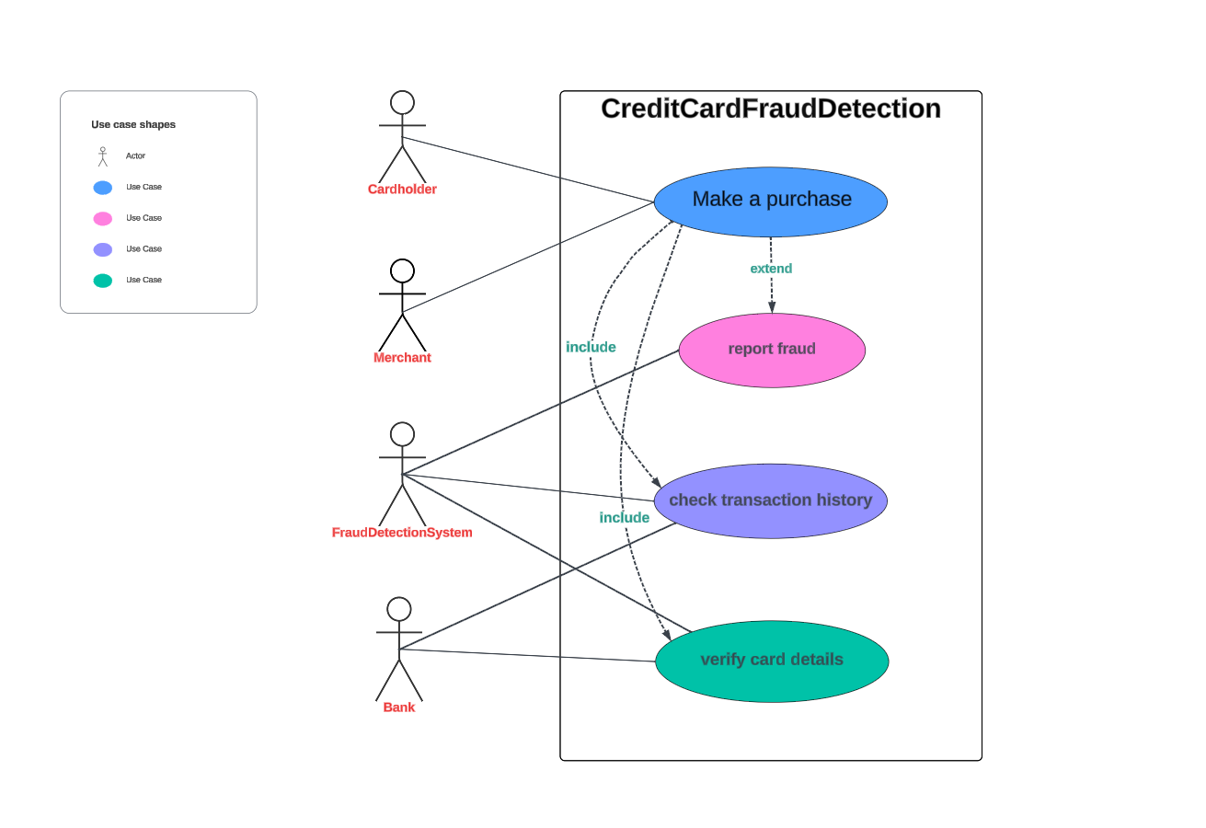
Figure 4 use case diagram
The use case diagram for the Credit Card Fraud Detection project illustrates the interactions among the actors and the system:
- Cardholder: Can perform two actions:
- Make a purchase: Initiates a transaction.
- Report fraud: Notifies the system of suspected fraudulent activity.
- Merchant: Involved in the “Make a purchase” use case, representing the recipient of the transaction.
- Check transaction history: Reviews past transactions for irregularities.
- Verify card details: Confirms the authenticity of the card information provided.
- Bank: The central actor that interacts with the Fraud Detection System to facilitate the detection process.
The diagram shows that the “Report fraud” use case extends the functionality of the system by involving additional checks like transaction history and card details verification. This ensures a comprehensive approach to fraud detection.

3.3.2 Activity Diagram:
An activity diagram shows the sequence of actions and decisions that the system performs to achieve a specific goal or outcome. It helps to model the dynamic behaviour and the logic of the system.
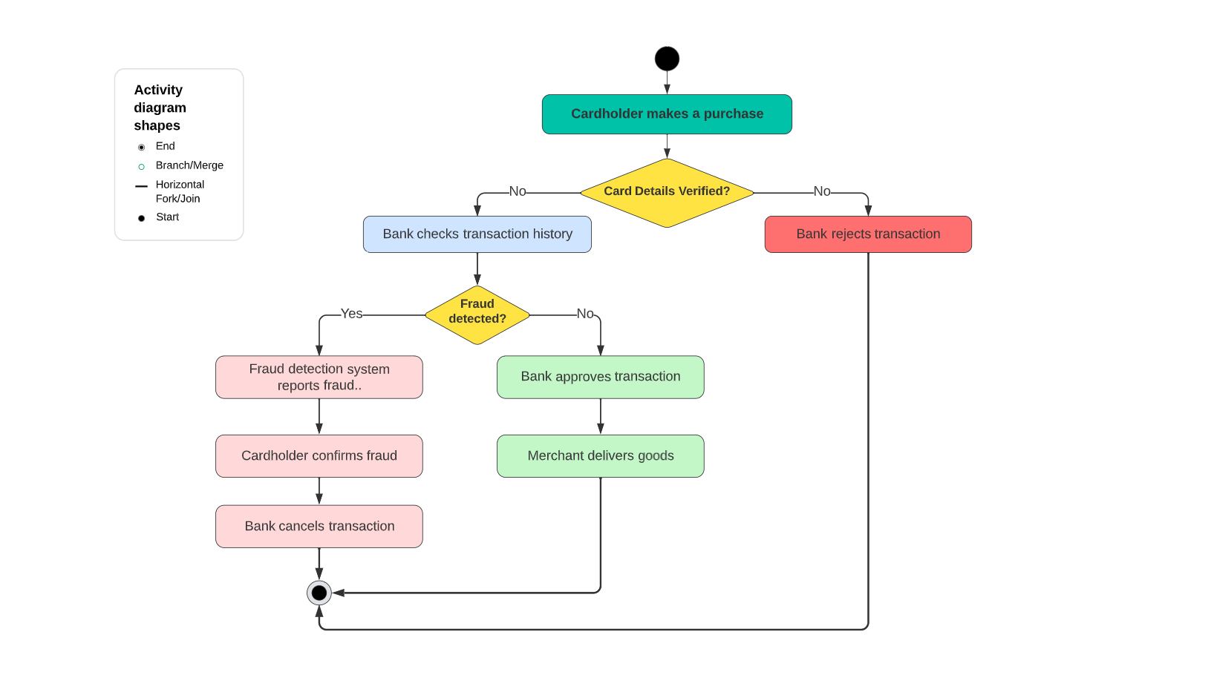
Figure 5Activity Diagram
The activity diagram from the project you mentioned outlines the process of credit card fraud detection:
Cardholder Transaction: It starts with a cardholder making a purchase.
Verification: The card details are then verified. If they are not verified, the bank rejects the transaction.
Fraud Check: If the card details are verified, the bank checks the transaction history for potential fraud.
Fraud Detection: If fraud is detected, the fraud detection system reports it.
Confirmation: The cardholder is then asked to confirm if the fraud is genuine.
Transaction Outcome: Depending on whether the fraud is confirmed, the bank either cancels the transaction or approves it, leading to the merchant delivering the goods.
This flow ensures that transactions are monitored and fraudulent activities are identified and handled promptly.

3.3.3 Class Diagram:
A class diagram shows the structure and the relationships of the classes and objects that make up the system. It helps to define the attributes, methods, and associations of the system components.
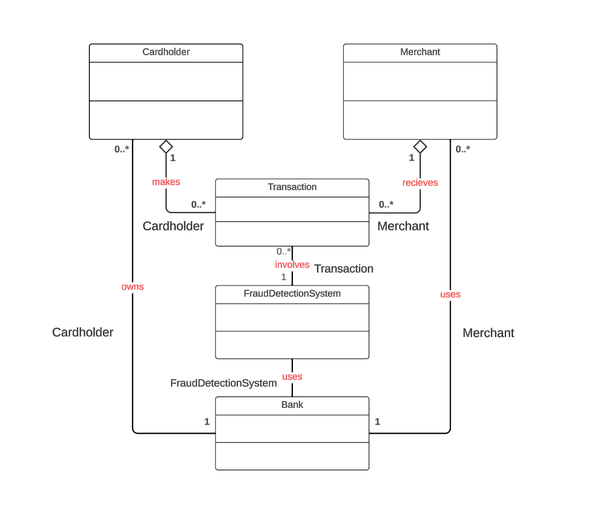
Figure 6Class diagram
The class diagram you’ve provided outlines the structure of a system designed for fraud detection in financial transactions. Here’s a breakdown of its components:
- Cardholder: Represents the individual who owns a payment card.
- Merchant: The entity that receives transactions from cardholders.
- Transaction: The action made by the cardholder, which involves transferring funds.
- FraudDetectionSystem: A system owned by the cardholder and used by both the merchant and the bank to detect fraudulent activities.
- Bank: The financial institution that uses the FraudDetectionSystem to oversee transactions.
- The relationships are as follows:
- A Cardholder makes a Transaction.
- A Merchant receives the Transaction.

3.3.4 Sequence Diagram:

A sequence diagram shows the interactions and the messages that are exchanged between the system components over time. It helps to illustrate the timing, order, and conditions of the communication and the collaboration of the system components.
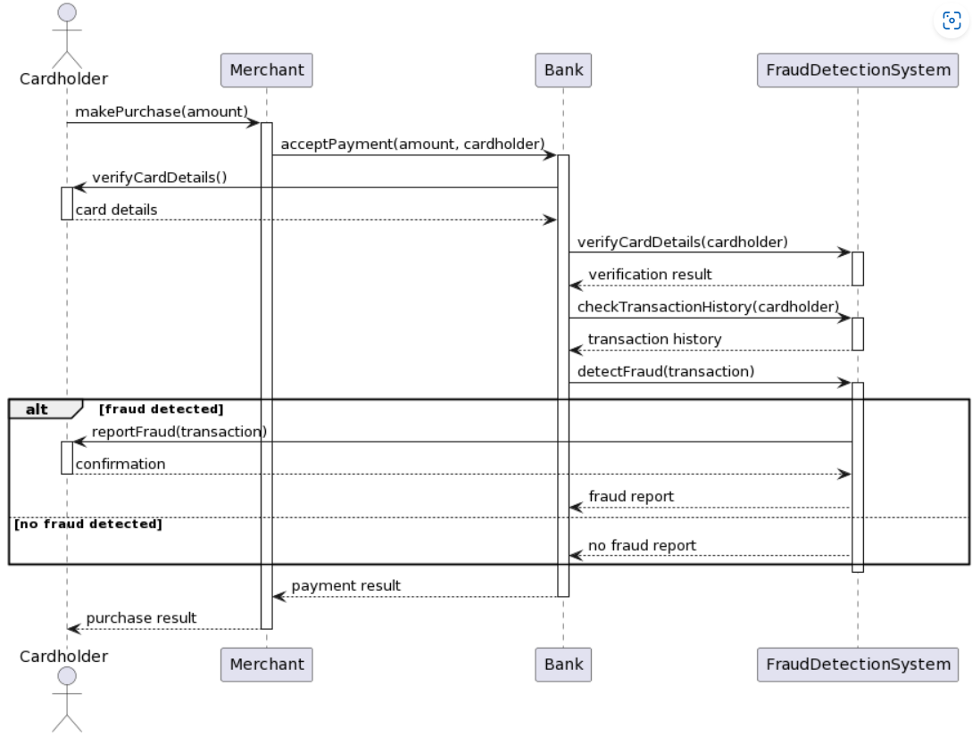
Figure 7Sequence diagram
The sequence diagram explanation:
  - Initiation: The Cardholder starts a purchase transaction.
  - Verification: The Merchant verifies the card details.
  - Payment Request: The Merchant requests payment acceptance from the Bank.
  - Fraud Check: The Bank checks the transaction history and the Fraud Detection System analyses the transaction for potential fraud.

- Outcome:
- If fraud is detected, a fraud report is sent to all parties.
- If no fraud is detected, the transaction proceeds normally, and the payment result is sent to the Merchant and Cardholder.
This diagram illustrates the collaborative steps taken by different entities to ensure secure transactions and prevent fraudulent activities.

3.4 Design: tools
There are many software tools and applications that can help me to draw or design the diagrams for my project. Like:
- LucidChart
- StarUML

3.5 The Evidence of consideration relation to the project

The "Credit Card Fraud Detection" project aims to address the social issue of credit card fraud, affecting consumers' trust and financial security. It adheres to professional standards in data handling and analysis, ensuring accuracy and reliability in fraud detection. Legal compliance is crucial, as it must comply with data privacy laws and regulations. Ethical considerations are essential, as the project must balance fraud detection with respect for individual privacy rights. A comprehensive approach considering all aspects of credit card fraud detection is essential for its effectiveness and responsibility.

Chapter 4: Implementation & Testing
- Software Development Lifecycle

    - Requirements Gathering and Analysis:
  - In this phase, the project team identifies the requirements for the fraud detection system. They analyse the problem domain, understand user needs, and define functional and non-functional requirements.
  - For this project, the primary requirement is to build an effective fraud detection model that can accurately classify credit card transactions as fraudulent or legitimate.
  - In this stage, the project’s objectives are defined. For this kernel, the objective is to detect fraudulent credit card transactions using various predictive models.
  - The problem of imbalanced data (where fraudulent transactions are significantly underrepresented) is acknowledged.
  - This is the initial phase where you identify the needs and functionalities of the fraud detection system. Here's what it typically involves:
  - Stakeholder Interviews: Meet with stakeholders like business analysts, security personnel, and fraud investigators to understand their needs and expectations.
  - Data Exploration: Analyse historical transaction data to identify patterns of fraudulent and legitimate transactions.
  - Regulatory Requirements: Identify any relevant regulations or compliance standards that the system needs to meet.
  - Feature Prioritization: Based on the gathered information, prioritize the functionalities the system should have.

    - Design:
  - The design phase involves creating a high-level architecture and detailed specifications for the system.
  - In this project, the design would include:
    - Defining the data pre-processing steps (e.g., handling missing values, scaling features).
    - Selecting appropriate machine learning algorithms (e.g., logistic regression, random forests, neural networks).
    - Designing the evaluation metrics (e.g., precision-recall curve) to assess model performance.
    - System Architecture: Define the overall system architecture, including components like data ingestion pipelines, the machine learning model, and the alerting system.
    - Data Pre-processing Design: Design the process for cleaning, transforming, and preparing the transaction data for model training.
    - Model Selection: Choose a suitable machine learning model for fraud detection, considering factors like accuracy, interpretability, and computational efficiency.
    - Model Training Plan: Define the training process for the model, including data splitting techniques, hyperparameter tuning strategies, and evaluation metrics.
    - Data Collection and Exploration:
    - The dataset used in the kernel contains anonymized features related to credit card transactions. It includes both normal and fraudulent transactions.
    - Exploratory Data Analysis (EDA) is performed to understand the data distribution, identify patterns, and visualize features.
    - Data Pre-processing and Feature Engineering:
    - Data pre-processing involves cleaning, transforming, and preparing the data for modelling.
    - Features are scaled (likely using techniques like Standard-Scaler or Min-Max scaling) to ensure consistent ranges.
    - Feature engineering may involve creating new features or transforming existing ones to improve model performance.

    - Model selection and training (Algorithms &Technologies ):

-Technologies Used:
- *Flask Framework*:
Flask was chosen as the backend framework for its simplicity and flexibility in creating APIs and web applications.

- *HTML/CSS*: HTML was used for structuring web pages, while CSS was utilized for styling the user interface to provide a visually appealing experience.

- *JavaScript*: JavaScript was employed to implement interactive features and handle client-side functionalities, such as form submission and dynamic content updates.

-Algorithms Used:
Involves a common approach to credit card fraud detection which typically includes several technologies
Data Pre-processing: This includes handling missing values, encoding categorical variables, and normalizing or standardizing the data. Since credit card datasets are usually imbalanced, techniques like oversampling the minority class or under-sampling the majority class might be used.
Feature Selection: Selecting the most relevant features that contribute to the predictive model’s performance. This could be done through statistical tests, selection algorithms, or using domain knowledge.
Model Training: Various machine learning algorithms can be used for fraud detection. Common choices include:
Logistic Regression: A linear model for classification tasks.
Decision Trees: A non-linear model that splits the data based on certain criteria.
Random Forest: An ensemble of decision trees that improves model performance and generalization.
Neural Networks: Can capture complex patterns through layers of neurons.
Anomaly Detection Algorithms: Such as Isolation Forest, which isolates anomalies instead of profiling normal data points.
Model Evaluation: Using metrics like accuracy, precision, recall, F1-score, and ROC-AUC to evaluate the model’s performance. In imbalanced datasets, precision-recall curves and F1-score are often more informative than accuracy.
Model Tuning: Adjusting the model’s hyperparameters to improve performance, often done through techniques like grid search or random search.
Deployment: Integrating the model into the existing system to start predicting real-time transactions.
They might have also employed techniques like Principal Component Analysis (PCA) to reduce dimensionality while retaining the most important variance in the data.

  - 4.1.3.1 The Logistic regression (The best choice):

Logistic regression is efficient in credit card fraud detection for several reasons:

- Interpretability: The model coefficients indicate the importance of each feature in predicting fraud.
- Efficiency: Logistic regression is computationally efficient and can handle large datasets with a moderate number of features.
- Scalability: It scales well with data size and is robust to noise.
- Probabilistic Output: Logistic regression provides probabilistic outputs, allowing for risk assessment and decision-making based on confidence levels.
- Considerations and Limitations
- Linear Decision Boundary: Logistic regression assumes a linear relationship between features and the log-odds of the target, which may not capture complex patterns in highly nonlinear data.
- Feature Engineering: Performance depends on selecting relevant features and handling data pre-processing effectively.
- Imbalanced Data: Logistic regression may require techniques to handle class imbalance, common in fraud detection tasks.

- Application in Fraud Detection
In credit card fraud detection, logistic regression can be part of a broader ensemble of algorithms or used in combination with anomaly detection techniques to enhance fraud detection performance. It provides a baseline model for binary classification and can serve as a starting point for more complex models.

    - Implementation and Coding:
  - In this project, they would create Jupyter notebooks or Python scripts to pre-process the data, train machine learning models, and evaluate their performance.
  - Predictive Models: Explores various predictive models to assess their accuracy in detecting fraud
- 4.1.4.1 Important Overview:
In this kernel we will use various predictive models to see how accurate they are in detecting whether a transaction is a normal payment or a fraud. As described in the dataset, the features are scaled and the names of the features are not shown due to privacy reasons. Nevertheless, we can still analyse some important aspects of the dataset. Let's start!

  - 4.1.4.2 Goals of implementation:
- Understand the little distribution of the "little" data that was provided to us.
- Create a 50/50 sub-data-frame ratio of "Fraud" and "Non-Fraud" transactions. (NearMiss Algorithm)
- Determine the Classifiers we are going to use and decide which one has a higher accuracy.
- Create a Neural Network and compare the accuracy to our best classifier.
- Understand common mistakes made with imbalanced datasets.

      - Information and screenshots of the implementation:

  - I. Understanding our data
a) Gather Sense of our data
- The transaction amount is relatively small. The mean of all the mounts made is approximately USD 88.
- There are no "Null" values, so we don't have to work on ways to replace values.
- Most of the transactions were Non-Fraud (99.83%) of the time, while Fraud transactions occurs (017%) of the time in the data-frame.
Distributions: By seeing the distributions we can have an idea how skewed are these features, we can also see further distributions of the other features. There are techniques that can help the distributions be less skewed which will be implemented in this notebook in the future.

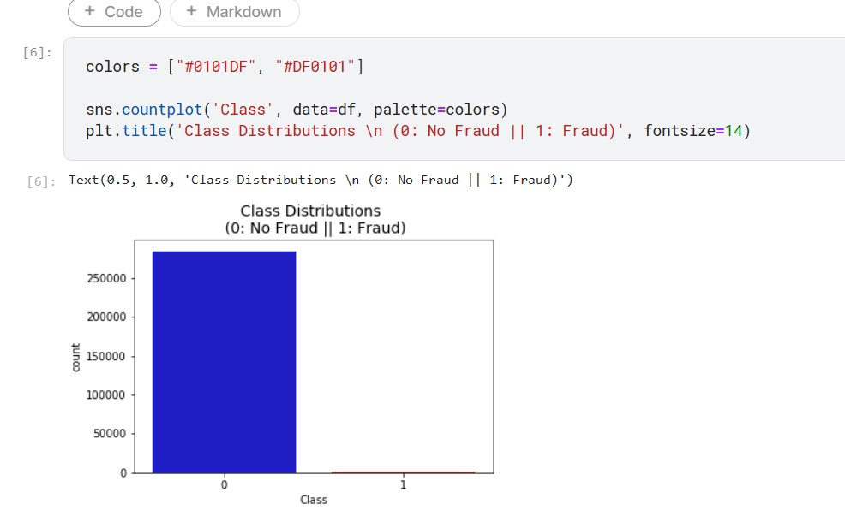

By seeing the distributions we can have an idea how skewed are these features, we can also see further distributions of the other features. There are techniques that can help the distributions be less skewed which will be implemented in this notebook in the future.

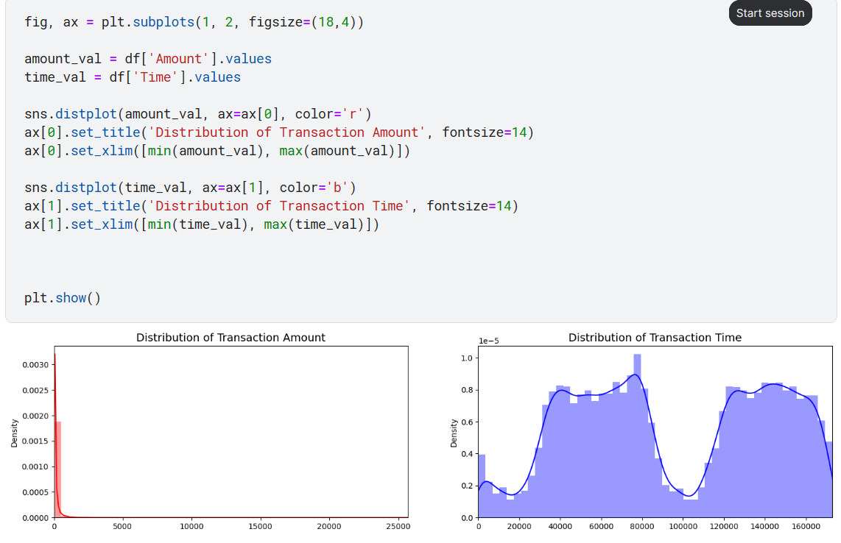

- II. Pre-processing
a) Scaling and Distributing
- In this phase of our kernel, we will first scale the columns comprise of Time and Amount. Time and amount should be scaled as the other columns. On the other hand, we need to also create a sub sample of the data-frame in order to have an equal amount of Fraud and Non-Fraud cases, helping our algorithms better understand patterns that determines whether a transaction is a fraud or not.
- Scaled amount and scaled time are the columns with scaled values. There are 492 cases of fraud in our dataset so we can randomly get 492 cases of non-fraud to create our new sub data-frame.
- We concat the 492 cases of fraud and non-fraud, creating a new sub-sample.
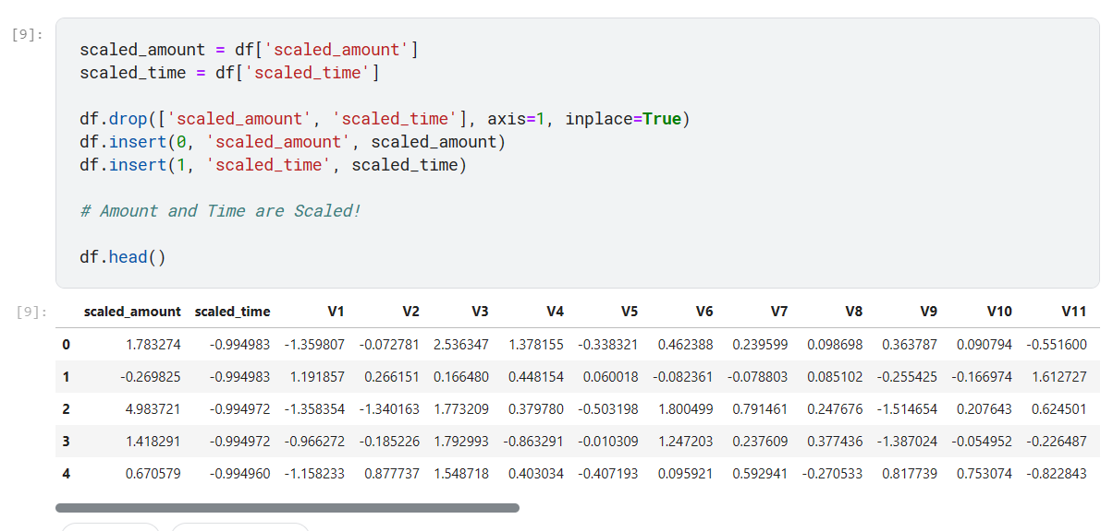

b) Splitting the Data
(Original Data-Frame)
Before proceeding with the Random Under-Sampling technique we have to separate the original data-frame. Why? For testing purposes, remember although we are splitting the data when implementing Random Under-Sampling or Over-Sampling techniques, we want to test our models on the original testing set not on the testing set created by either of these techniques. The main goal is to fit the model either with the data-frames that were under-sample and oversample (in order for our models to detect the patterns), and test it on the original testing set.
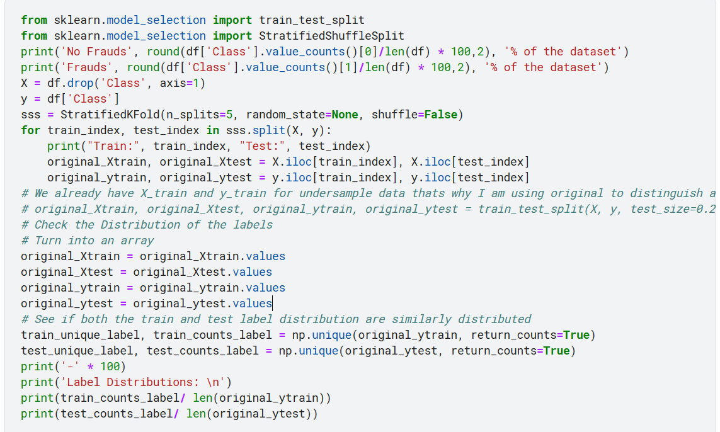
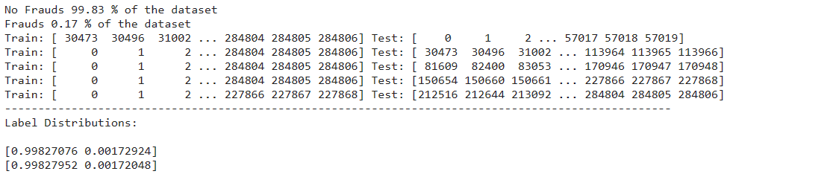

- III. Random Under-Sampling and Oversampling
In this phase of the project we will implement *"Random Under-Sampling"* which basically consists of removing data in order to have a more balanced dataset and thus avoiding our models to overfitting.

Steps:
- The first thing we have to do is determine how imbalanced is our class (use "value counts()" on the class column to determine the amount for each label)
- Once we determine how many instances are considered fraud transactions (Fraud = "1") , we should bring the non-fraud transactions to the same amount as fraud transactions (assuming we want a 50/50 ratio), this will be equivalent to 492 cases of fraud and 492 cases of non-fraud transactions.
- After implementing this technique, we have a sub-sample of our data-frame with a 50/50 ratio with regards to our classes. Then the next step we will implement is to shuffle the data to see if our models can maintain a certain accuracy every-time we run this script.
Note: The main issue with "Random Under-Sampling" is that we run the risk that our classification models will not perform as accurate as we would like to since there is a great deal of information loss (bringing 492 non-fraud transaction from 284,315 non-fraud transaction)
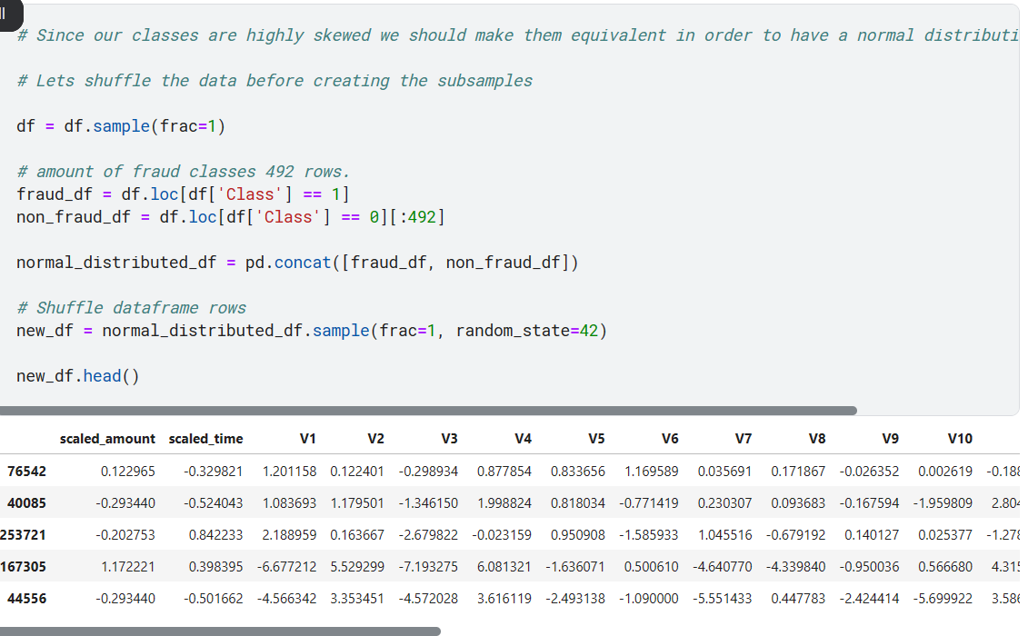

Equally Distributing and Correlating:
Now that we have our data-frame correctly balanced, we can go further with our analysis and data pre-processing.
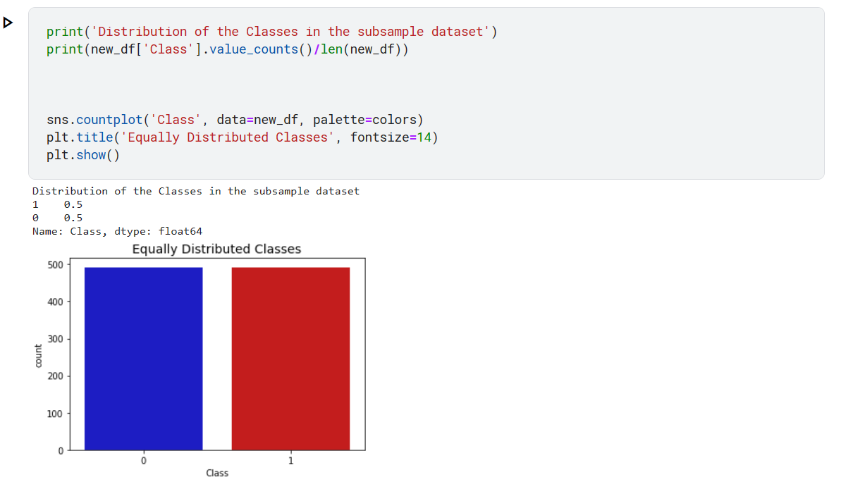

a) Distributing and Correlating
- Correlation Matrices
Correlation matrices are the essence of understanding our data. We want to know if there are features that influence heavily in whether a specific transaction is a fraud. However, it is important that we use the correct data-frame (subsample) in order for us to see which features have a high positive or negative correlation with regards to fraud transactions.

Summary and Explanation:
- Negative Correlations: V17, V14, V12 and V10 are negatively correlated. Notice how the lower these values are, the more likely the end result will be a fraud transaction.
- Positive Correlations: V2, V4, V11, and V19 are positively correlated. Notice how the higher these values are, the more likely the end result will be a fraud transaction.
- BoxPlots: We will use boxplots to have a better understanding of the distribution of these features in fraudulent and non-fraudulent transactions.
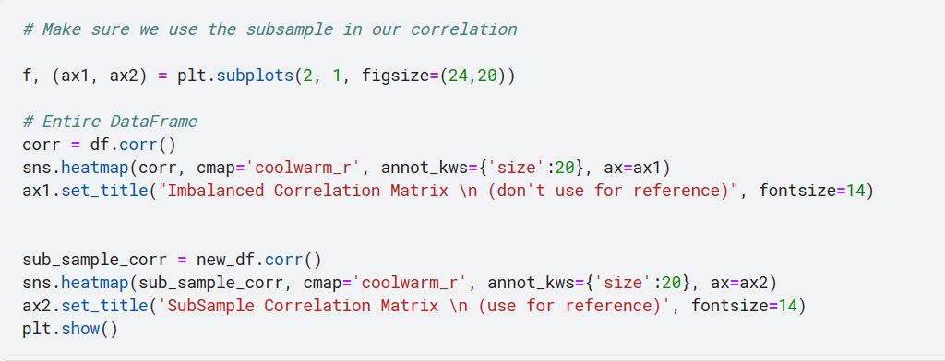
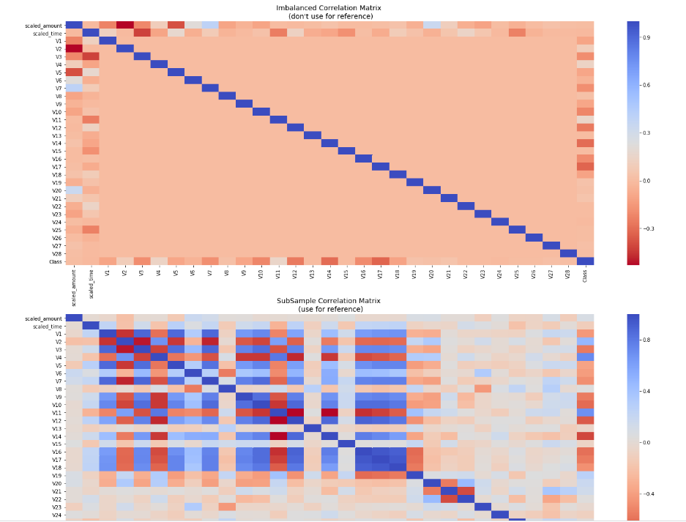
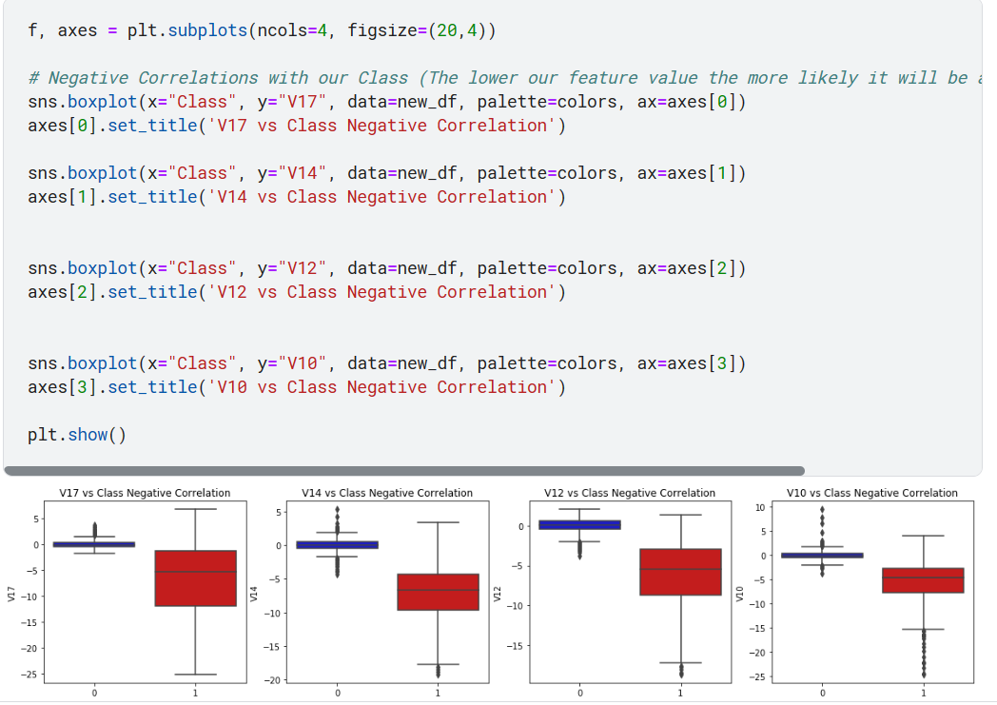

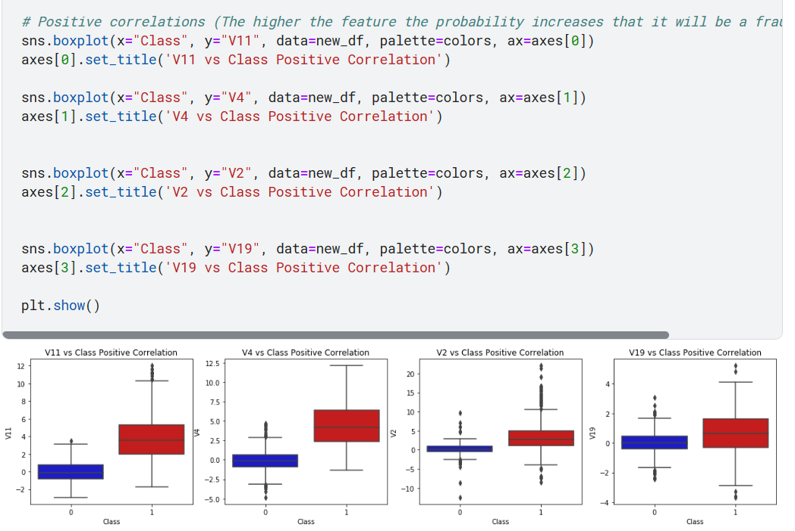
b) Anomaly Detection
Our main aim in this section is to remove "extreme outliers" from features that have a high correlation with our classes. This will have a positive impact on the accuracy of our models.
- Interquartile Range Method:
- Interquartile Range (IQR): We calculate this by the difference between the 75th percentile and 25th percentile. Our aim is to create a threshold beyond the 75th and 25th percentile that in case some instance pass this threshold the instance will be deleted.
- Boxplots: Besides easily seeing the 25th and 75th percentiles (both end of the squares) it is also easy to see extreme outliers (points beyond the lower and higher extreme).
- Summary:
- Visualize Distributions: We first start by visualizing the distribution of the feature we are going to use to eliminate some of the outliers. V14 is the only feature that has a Gaussian distribution compared to features V12 and V10.

- Determining the threshold: After we decide which number we will use to multiply with the iqr (the lower more outliers removed), we will proceed in determining the upper and lower thresholds by sub-starting q25 - threshold (lower extreme threshold) and adding q75 + threshold (upper extreme threshold).

- Conditional Dropping: Lastly, we create a conditional dropping stating that if the "threshold" is exceeded in both extremes, the instances will be removed.

- Boxplot Representation: Visualize through the boxplot that the number of "extreme outliers" have been reduced to a considerable amount.

Note: After implementing outlier reduction our accuracy has been improved by over 3%! Some outliers can distort the accuracy of our models but remember, we have to avoid an extreme amount of information loss or else our model runs the risk of underfitting.
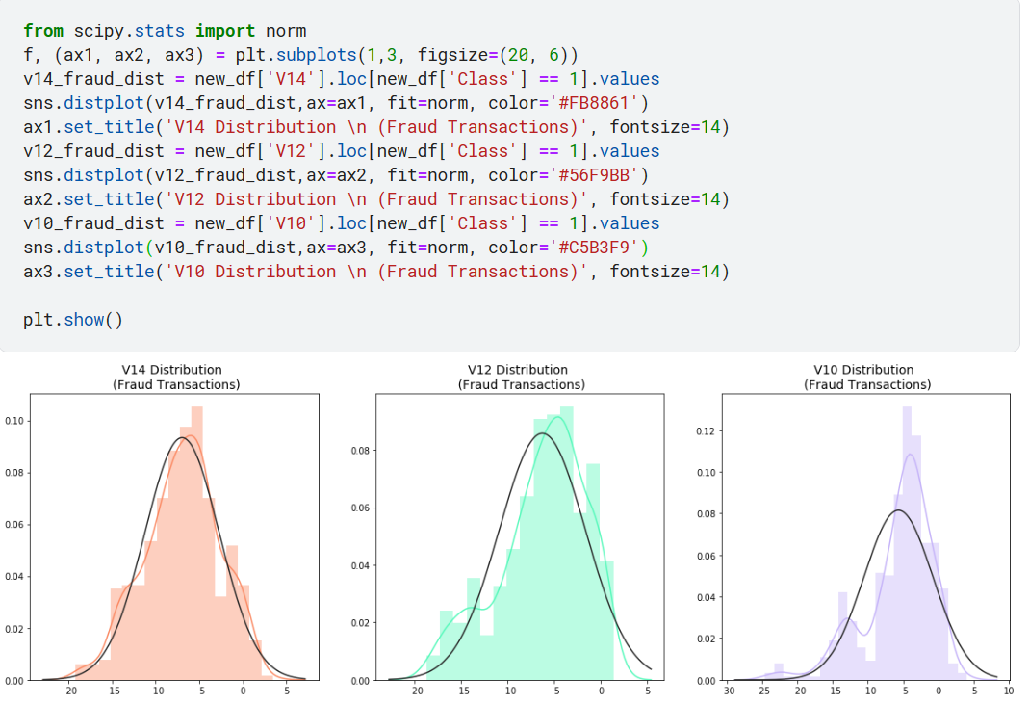
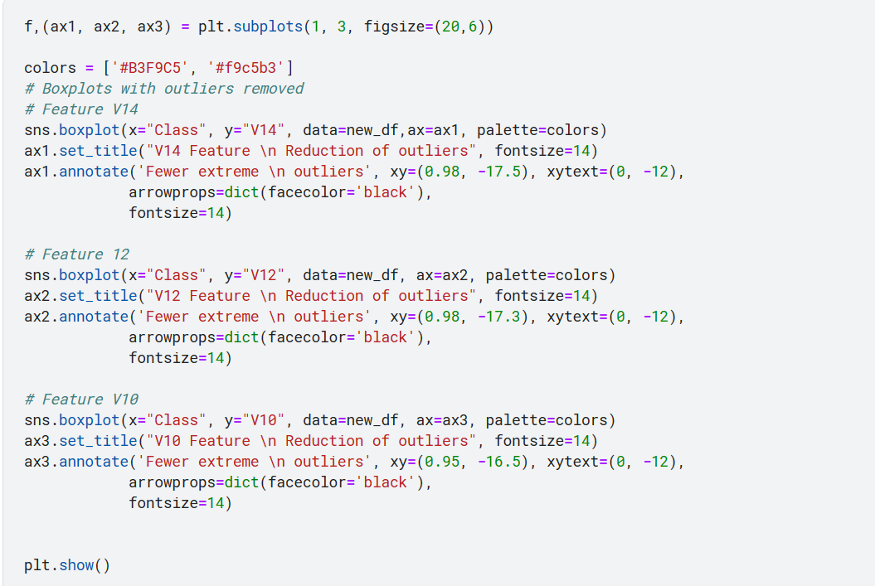
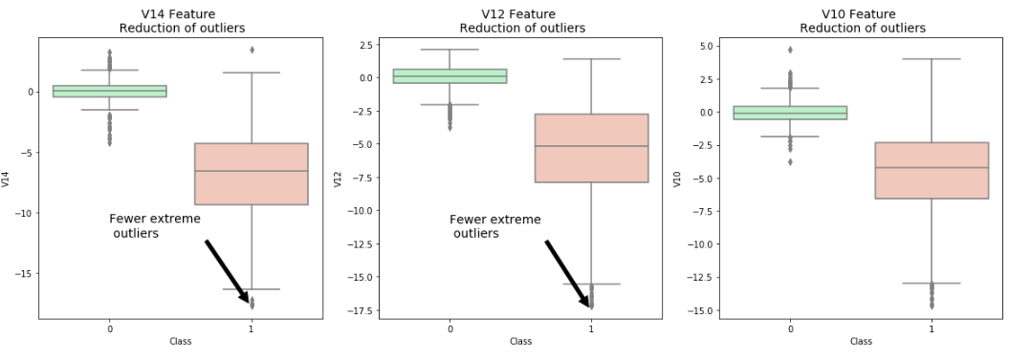

c) Dimensionality Reduction and Clustering (t-SNE)
- Understanding t-SNE:
In order to understand this algorithm you have to understand the following terms:
- Euclidean Distance
- Conditional Probability
- Normal and T-Distribution Plots
Note: If you want a simple instructive video look at StatQuest: t-SNE, Clearly Explained by Joshua Starmer
. Summary:
- t-SNE algorithm can pretty accurately cluster the cases that were fraud and non-fraud in our dataset.
- Although the subsample is pretty small, the t-SNE algorithm is able to detect clusters pretty accurately in every scenario (I shuffle the dataset before running t-SNE)
- This gives us an indication that further predictive models will perform pretty well in separating fraud cases from non-fraud cases.
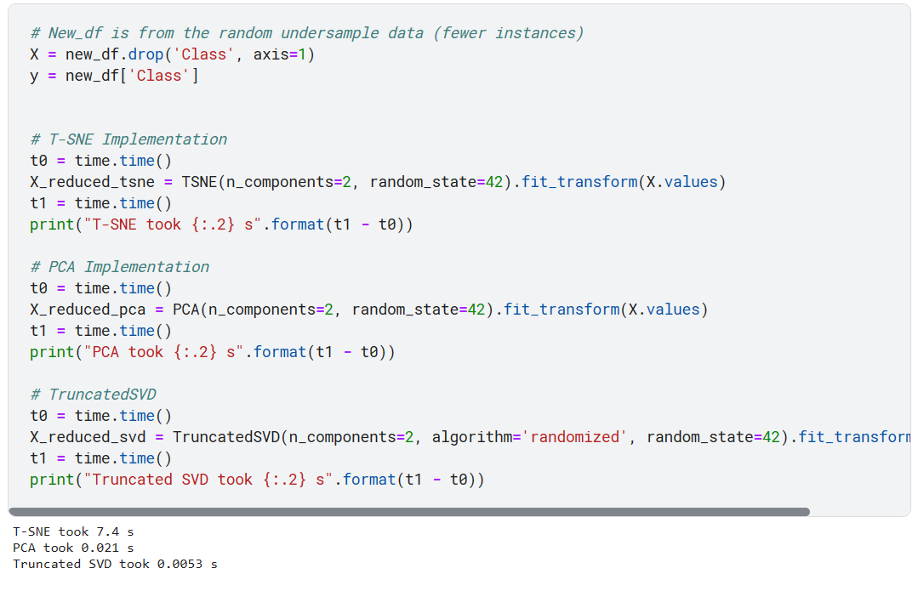
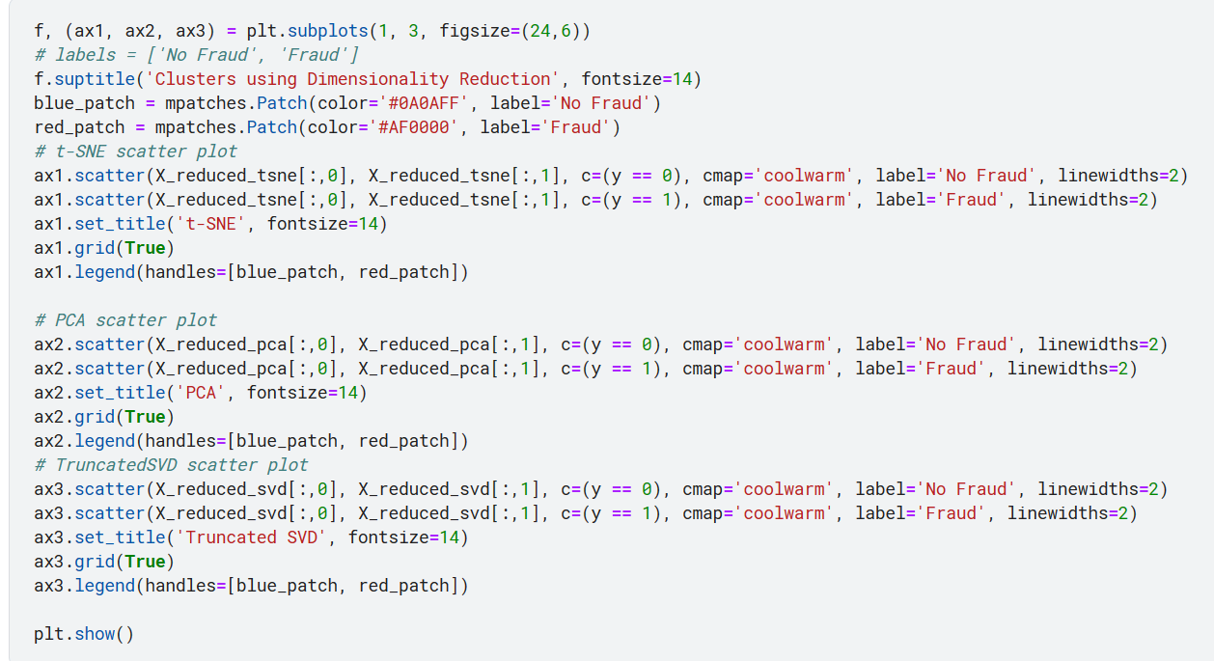
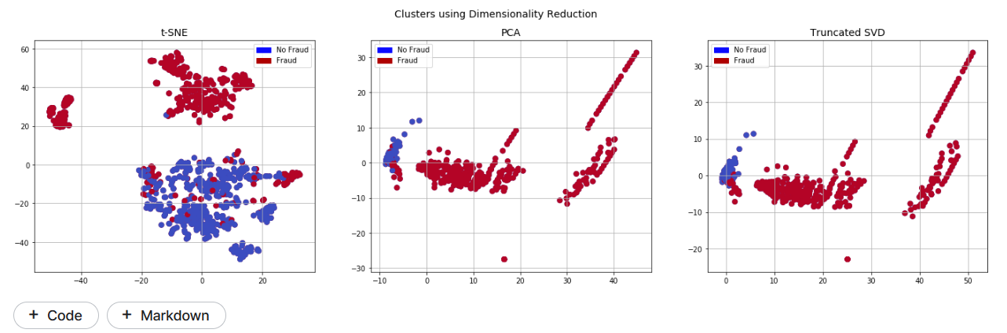
d) Classifiers
- Classifiers (Under-Sampling):
In this section we will train four types of classifiers and decide which classifier will be more effective in detecting fraud transactions. Before we have to split our data into training and testing sets and separate the features from the labels. –
- Summary:
- Logistic Regression classifier is more accurate than the other three classifiers in most cases. (We will further analyse Logistic Regression)
- GridSearchCV is used to determine the paremeters that gives the best predictive score for the classifiers.
- Logistic Regression has the best Receiving Operating Characteristic score (ROC), meaning that LogisticRegression pretty accurately separates fraud and non-fraud transactions.
- Learning Curves:
- The wider the gap between the training score and the cross validation score, the more likely your model is overfitting (high variance).
- If the score is low in both training and cross-validation sets this is an indication that our model is underfitting (high bias)
- Logistic Regression Classifier shows the best score in both training and cross-validating sets.
- Classifiers: LogisticRegression Has a training score of 93.0 % accuracy score
- Classifiers: KNeighborsClassifier Has a training score of 93.0 % accuracy score
- Classifiers: SVC Has a training score of 93.0 % accuracy score
- Classifiers: DecisionTreeClassifier Has a training score of 92.0 % accuracy score
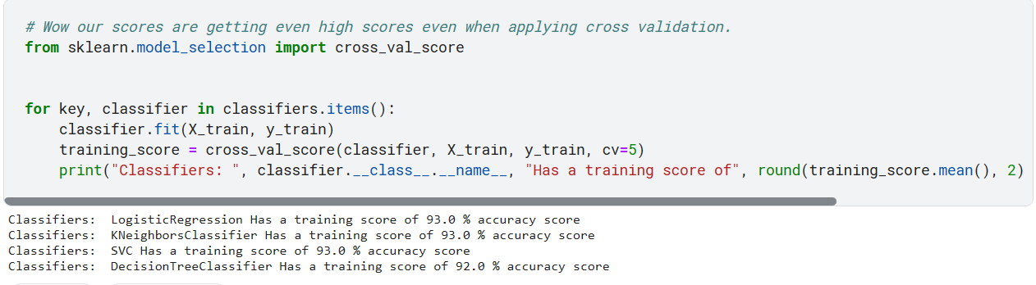
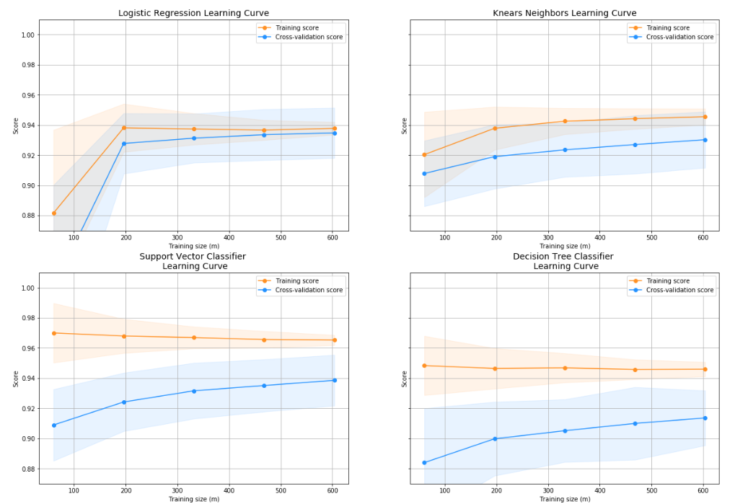

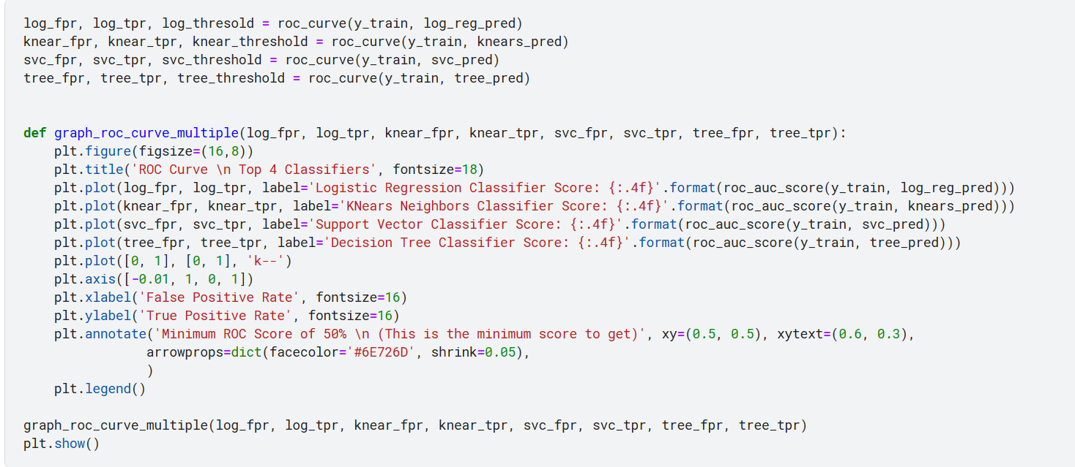
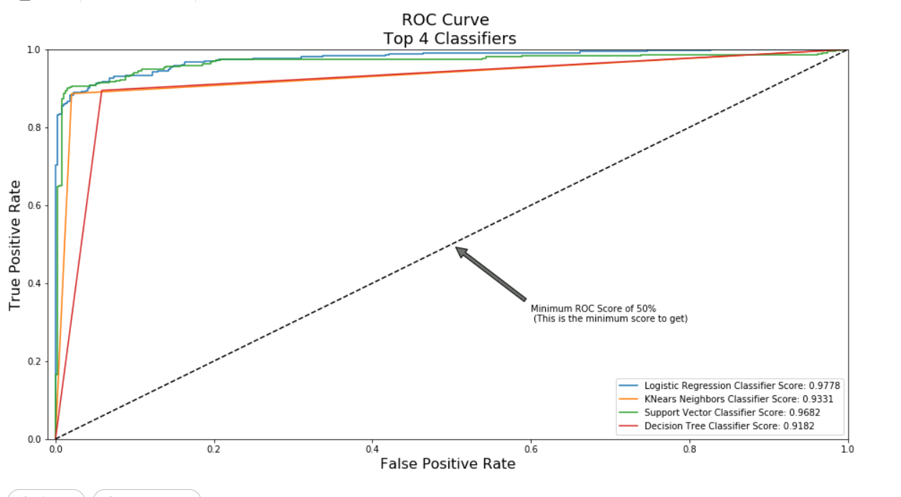
e) A Deeper Look into Logistic Regression
In this section we will ive a deeper look into the logistic regression classifier.
- Terms:
- True Positives: Correctly Classified Fraud Transactions
- False Positives: Incorrectly Classified Fraud Transactions
- True Negative: Correctly Classified Non-Fraud Transactions
- False Negative: Incorrectly Classified Non-Fraud Transactions
- Precision: True Positives/(True Positives + False Positives)
- Recall: True Positives/(True Positives + False Negatives)
- Precision as the name says, says how precise (how sure) is our model in detecting fraud transactions while recall is the amount of fraud cases our model is able to detect.
- Precision/Recall Tradeoff: The more precise (selective) our model is, the less cases it will detect. Example: Assuming that our model has a precision of 95%, Let's say there are only 5 fraud cases in which the model is 95% precise or more that these are fraud cases. Then let's say there are 5 more cases that our model considers 90% to be a fraud case, if we lower the precision there are more cases that our model will be able to detect.

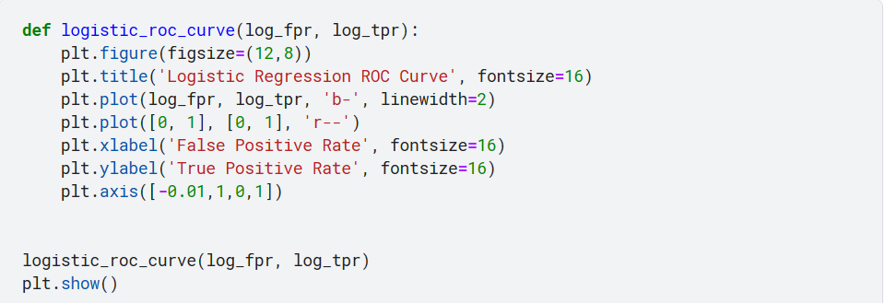
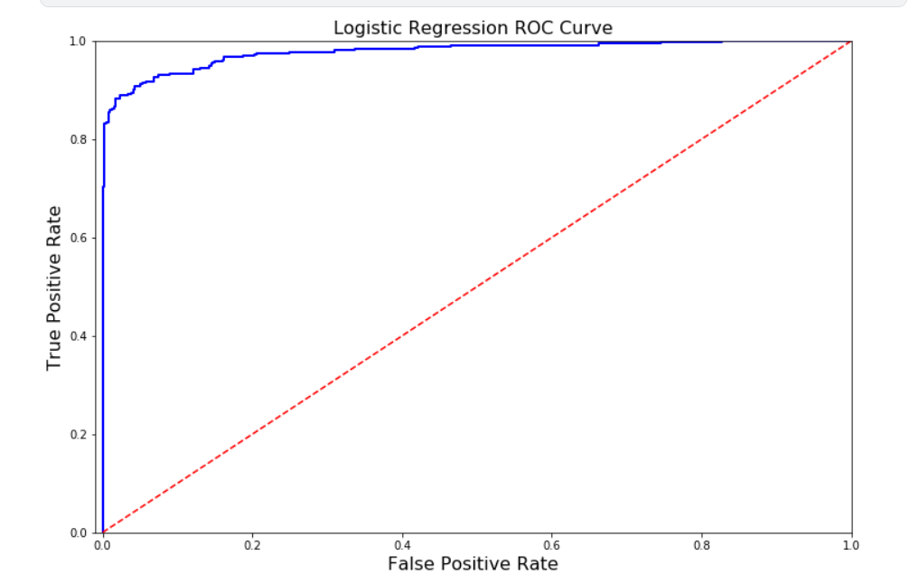
f) Oversampling with SMOTE
SMOTE stands for Synthetic Minority Over-sampling Technique. Unlike Random UnderSampling, SMOTE creates new synthetic points in order to have an equal balance of the classes. This is another alternative for solving the "class imbalance problems".
Understanding SMOTE:
- Solving the Class Imbalance: SMOTE creates synthetic points from the minority class in order to reach an equal balance between the minority and majority class.
- Location of the synthetic points: SMOTE picks the distance between the closest neighbors of the minority class, in between these distances it creates synthetic points.
- Final Effect: More information is retained since we didn't have to delete any rows unlike in random under-sampling.
- Accuracy || Time Tradeoff: Although it is likely that SMOTE will be more accurate than random under-sampling, it will take more time to train since no rows are eliminated as previously stated.
- n our undersample analysis I want to show you a common mistake I made that I want to share with all of you. It is simple, if you want to undersample or oversample your data you should not do it before cross validating. Why because you will be directly influencing the validation set before implementing cross-validation causing a "data leakage" problem.
- In the following section you will see amazing precision and recall scores but in reality our data is overfitting!
- The Wrong Way:
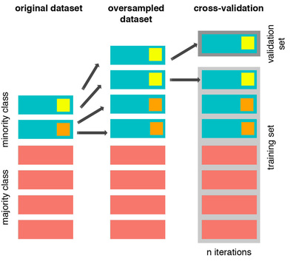
- As mentioned previously, if we get the minority class ("Fraud) in our case, and create the synthetic points before cross validating we have a certain influence on the "validation set" of the cross validation process. Remember how cross validation works, let's assume we are splitting the data into 5 batches, 4/5 of the dataset will be the training set while 1/5 will be the validation set. The test set should not be touched! For that reason, we have to do the creation of synthetic datapoints "during" cross-validation and not before, just like below:

The Right Way:
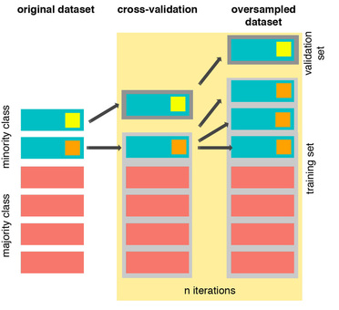
- As you see above, SMOTE occurs "during" cross validation and not "prior" to the cross validation process. Synthetic data are created only for the training set without affecting the validation set.

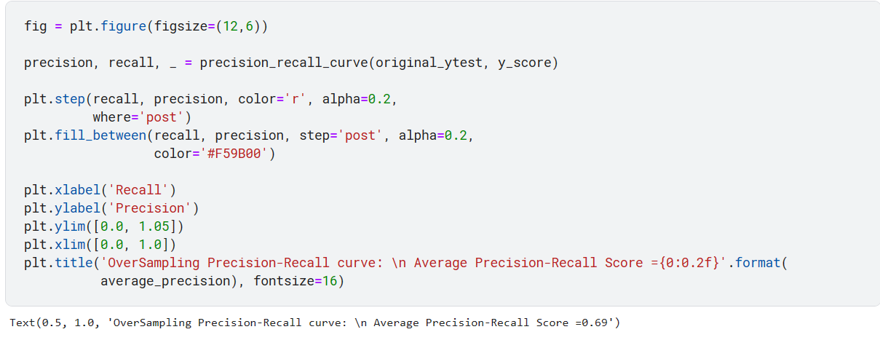
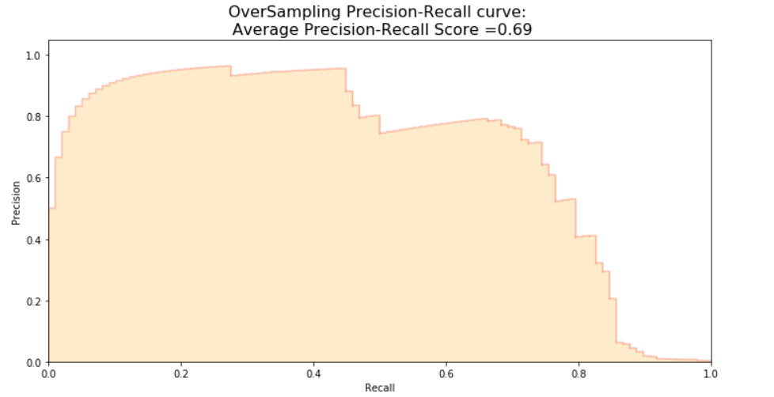

    - Testing:

- IV. Testing

  - The testing phase ensures that the system behaves correctly and meets the specified requirements.
  - For this project, testing involves:
    - Splitting the dataset into train, validation, and test sets.
    - Training models on the training data and evaluating them on the validation set.
    - Tuning hyperparameters to improve model performance.
4.1.5.1 Testing with Logistic Regression

Confusion Matrix:
Positive/Negative: Type of Class (label) ["No", "Yes"] True/False: Correctly or Incorrectly classified by the model.
True Negatives (Top-Left Square): This is the number of correctly classifications of the "No" (No Fraud Detected) class.
False Negatives (Top-Right Square): This is the number of incorrectly classifications of the "No"(No Fraud Detected) class.
False Positives (Bottom-Left Square): This is the number of incorrectly classifications of the "Yes" (Fraud Detected) class
True Positives (Bottom-Right Square): This is the number of correctly classifications of the "Yes" (Fraud Detected) class.

Summary:
- Random UnderSampling: We will evaluate the final performance of the classification models in the random undersampling subset. Keep in mind that this is not the data from the original dataframe.
- Classification Models: The models that performed the best were logistic regression and support vector classifier (SVM)
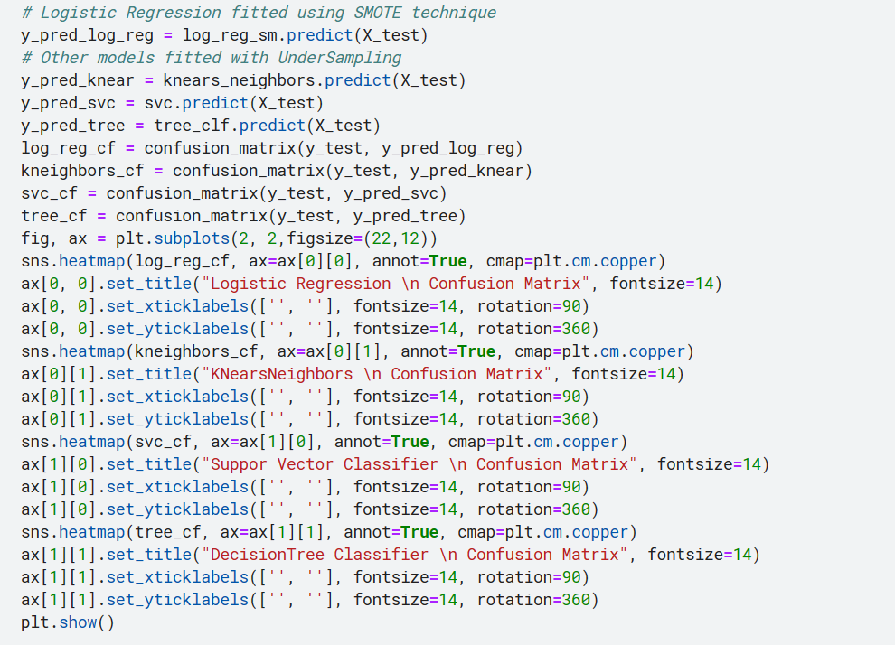
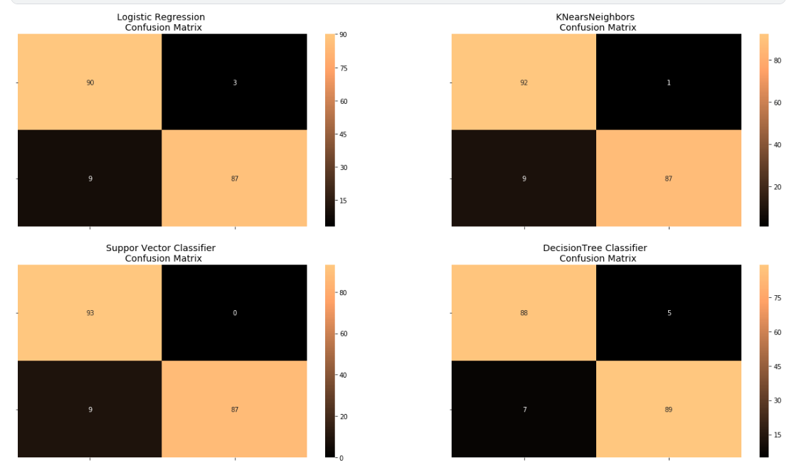
4.1.5.2 Neural Networks Testing (Under-sampling vs Oversampling)
In this section we will implement a simple Neural Network (with one hidden layer) in order to see which of the two logistic regressions models we implemented in the (undersample or oversample(SMOTE)) has a better accuracy for detecting fraud and non-fraud transactions.

Our Main Goal:
Our main goal is to explore how our simple neural network behaves in both the random undersample and oversample dataframes and see whether they can predict accuractely both non-fraud and fraud cases. Why not only focus on fraud? Imagine you were a cardholder and after you purchased an item your card gets blocked because the bank's algorithm thought your purchase was a fraud. That's why we shouldn't emphasize only in detecting fraud cases but we should also emphasize correctly categorizing non-fraud transactions.

The Confusion Matrix:
Here is again, how the confusion matrix works:
- Upper Left Square: The amount of correctly classified by our model of no fraud transactions.
- Upper Right Square: The amount of incorrectly classified transactions as fraud cases, but the actual label is no fraud .
- Lower Left Square: The amount of incorrectly classified transactions as no fraud cases, but the actual label is fraud .
- Lower Right Square: The amount of correctly classified by our model of fraud transactions.

Summary (Keras || Random UnderSampling):
- Dataset: In this final phase of testing we will fit this model in both the random undersampled subset and oversampled dataset (SMOTE) in order to predict the final result using the original dataframe testing data.
- Neural Network Structure: As stated previously, this will be a simple model composed of one input layer (where the number of nodes equals the number of features) plus bias node, one hidden layer with 32 nodes and one output node composed of two possible results 0 or 1 (No fraud or fraud).
- Other characteristics: The learning rate will be 0.001, the optimizer we will use is the AdamOptimizer, the activation function that is used in this scenario is "Relu" and for the final outputs we will use sparse categorical cross entropy, which gives the probability whether an instance case is no fraud or fraud (The prediction will pick the highest probability between the two.)
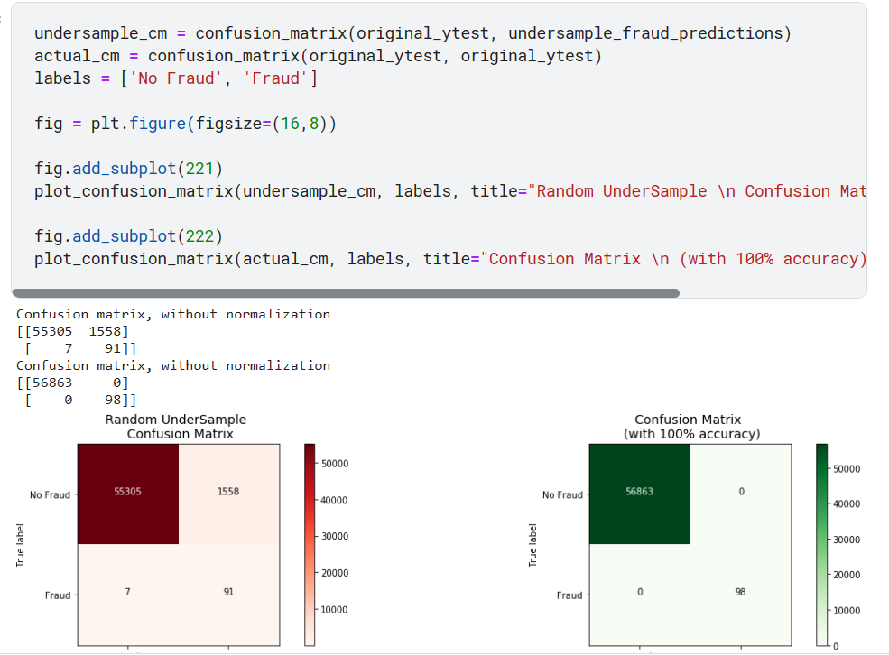

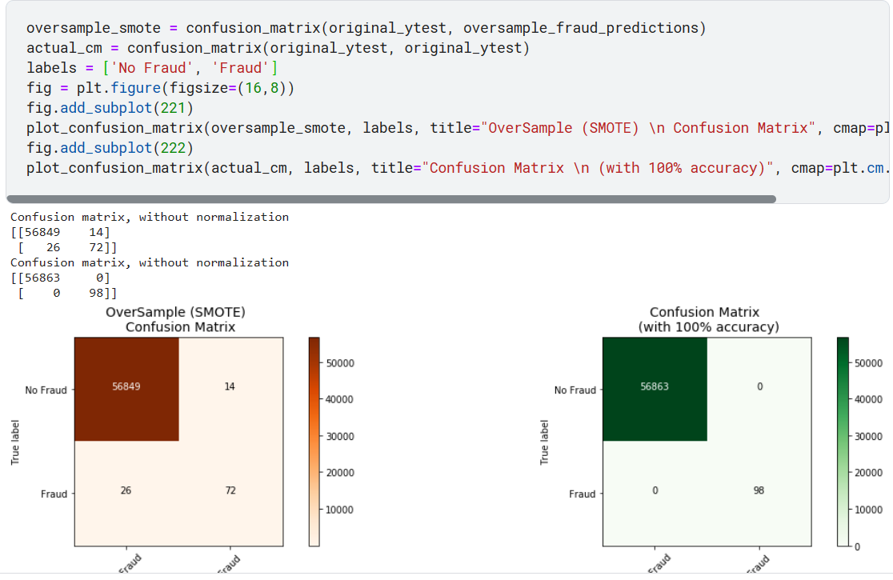
4.1.5.3 Testing the Model:
- By using a Flask code to make an API to the user to use the Credit Card Fraud Detection System and check if the transition is fraudulent or not-fraudulent:
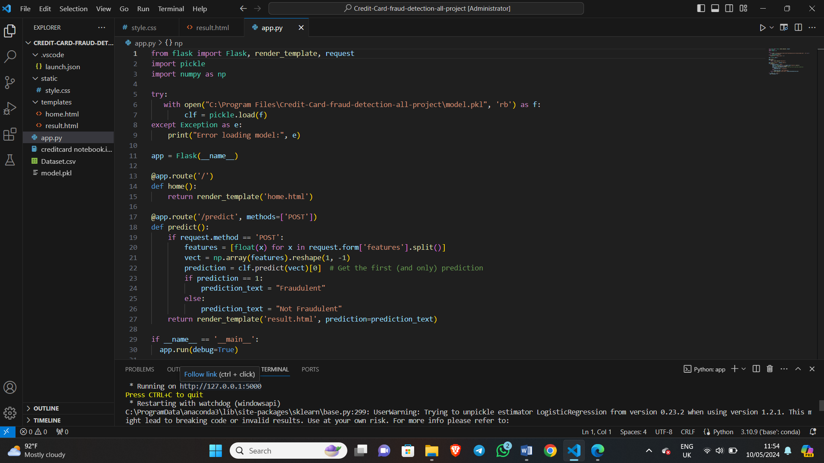
- In the dataset you’ve linked, the columns labelled [V1, V2… V28] [time, amount] represent anonymized features derived from a PCA transformation. These features are used for credit card fraud detection. Specifically:
- V1: Anonymized feature 1
- V2: Anonymized feature 2
These features are part of the input data used by machine learning models to predict whether a credit card transaction is fraudulent or legitimate.
- The user input that 30 features in the system:

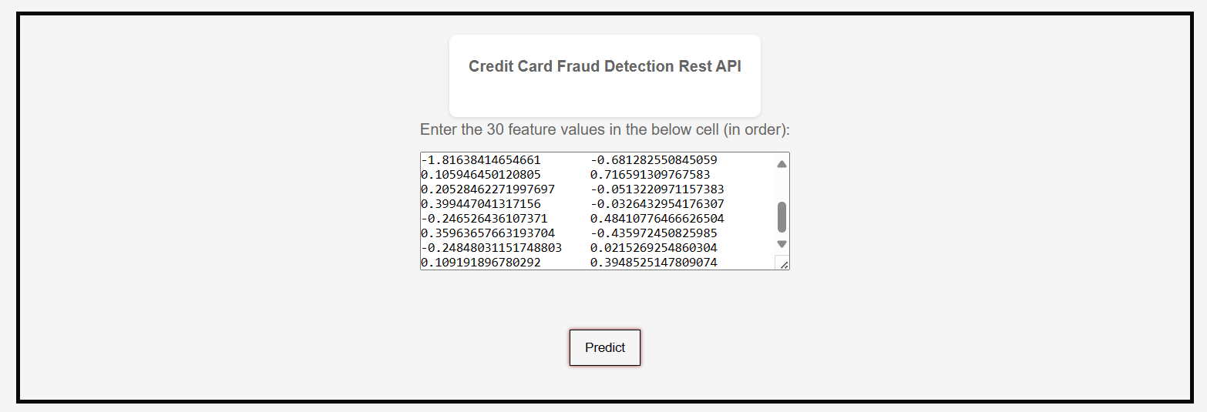

- And wait for testing the transition:

- The prediction of this transition is: Not-fraudulent

    - Deployment and Integration:
  - Once the model performs well in testing, it can be deployed to a production environment.
  - Integration with other systems (e.g., a banking platform) may be necessary.
  - In this project, deployment could involve deploying the model as an API or integrating it into an existing fraud detection system.
  - This is where you implement the designed system and integrate it with existing infrastructure. Here are the key steps:
    - Environment Setup: Set up the necessary infrastructure (cloud or on premise) to run the system.
    - Model Deployment: Deploy the trained model to a production environment where it can score incoming transactions.
    - Integration: Integrate the fraud detection system with other existing systems, like transaction processing systems or alert notification systems.
    - Testing: Perform comprehensive testing to ensure the deployed system functions as designed and integrates seamlessly with other systems.

    - Maintenance and Monitoring:

- Model Retraining: Fraudsters constantly develop new techniques. The fraud detection model needs to be retrained periodically with new data containing the latest fraudulent transactions. This ensures the model stays effective in identifying emerging fraud patterns.
- Data Monitoring: Monitor the quality and distribution of incoming transaction data. Check for anomalies or biases that might affect the model's performance.
- Alerting System: Set up an alert system to notify relevant personnel when metrics like fraud rate or model accuracy deviate significantly from expected values. This enables prompt investigation and potential model retraining.
- System Performance Monitoring: Monitor the system's uptime, resource utilization, and response times. Ensure smooth operation and identify potential bottlenecks.

    - Documentation and User Training:

- System Documentation: Create comprehensive documentation describing the system architecture, data pipelines, model selection process, training procedures, and evaluation metrics. This ensures knowledge transfer and facilitates future maintenance and updates.
- User Training: Train personnel who will be using or interacting with the system. This might include analysts who investigate flagged transactions and business stakeholders who need to understand the system's capabilities and limitations. Training should cover how to interpret results, identify false positives, and escalate suspicious cases.

- The database design:

- Dataset Overview:

    - The dataset used in this project contains anonymized features related to credit card transactions.
    - It includes both normal (non-fraudulent) and fraudulent transactions.
    - Each transaction is represented by various features (e.g., transaction amount, timestamp, merchant information) that provide context for modelling.

- Database Design Considerations:

We can discuss the design considerations if this were part of a larger system:
- Tables: The dataset would likely be stored in one or more tables within a relational database.

- Schema: The schema would define the structure of the tables, including column names, data types, and relationships.

- Normalization: Ensuring the data is in an appropriate normal form to minimize redundancy and improve efficiency.

- Indexes: Creating indexes on relevant columns (e.g., transaction ID, customer ID) for faster querying.

- Data Types: Choosing appropriate data types (e.g., numeric, text, date-time) for each column.

- Constraints: Defining constraints (e.g., primary keys, foreign keys) to maintain data integrity.

- Security: Implementing access controls, encryption, and authentication to protect sensitive data.

- Feature Extraction and Transformation:
The dataset features (columns) would map to database table columns.
Feature engineering involves creating new features (e.g., aggregations, ratios) based on existing ones.
Data transformations (e.g., scaling, normalization) are applied to ensure consistent ranges.

- Handling Imbalanced Data:
The kernel addresses the challenge of imbalanced data by using techniques like oversampling (creating synthetic instances of the minority class) and under-sampling (reducing instances of the majority class).
These techniques balance the representation of normal and fraudulent transactions.

- Model Training and Evaluation:
The kernel explores various predictive models (e.g., logistic regression, random forest, neural networks) to detect fraud.
Model parameters, hyperparameters, and evaluation metrics are important considerations.

- Deployment and Monitoring:
In a real-world system, the trained model would be deployed for real-time fraud detection.
Monitoring the model’s performance and retraining as needed would be crucial.

- The software/deliverable

The project might build a more comprehensive fraud detection system. This system would likely involve several components working together. First, data pipelines would be implemented to ingest real-time or batch transaction data from various sources. This data would then be pre-processed to ensure it's in a format suitable for the machine learning model. The core of the system would be the machine learning model, trained to identify patterns indicative of fraudulent activity in transaction data. Once a new transaction is received, the system would use the scoring mechanism to evaluate it based on the model. If the score exceeds a predefined threshold, the transaction would be flagged as suspicious and an alert would be triggered through the alerting system. This alert would then be routed to the appropriate personnel for investigation.
---- - - - - - - ---

- Development kit – servers – requirements

- Development Kit: This refers to the tools and software used by developers to build the fraud detection system. Common components include:
    - Programming Languages: Python, R, or other languages for coding.
    - IDEs (Integrated Development Environments): Jupyter Notebook, PyCharm, or Visual Studio Code.
    - Version Control: Git for managing code changes.
- Servers:
The system is on a local server, but in the 6 months the system could be deployed on cloud servers (Azure).

- Requirements: These include both functional and non-functional requirements:
    - Functional requirements specify what the system should do (e.g., accurately detect fraud).
    - Non-functional requirements cover aspects like performance, security, and scalability.
We have discussed them in chapter 3 section 3.1

- Modules

  - Modules represent distinct components of the system. In the fraud detection project, modules might include:
    - Data Pre-processing Module: Cleans and prepares the credit card transaction data.
    - Feature Engineering Module: Creates relevant features (e.g., transaction frequency, time of day).
    - Machine Learning Module: Trains and evaluates fraud detection models.
    - Alerting Module: Generates alerts when potential fraud is detected.
    - Reporting Module: Provides insights and visualizations for analysts.
    - Model Monitoring Module: Ensures model performance over time.

- Services

- Services refer to functionalities provided by the system:
    - Fraud Detection Service: The core service that analyses transactions and identifies potential fraud.
    - API Service: Exposes endpoints for real-time fraud detection.
    - Batch Processing Service: Processes historical data in batches.
    - Model Retraining Service: Periodically retrains the machine learning model.
    - Logging and Monitoring Service: Tracks system health and performance.

- User Interface

  - The UI allows users (analysts, investigators) to interact with the system:
    - Dashboard: Displays real-time alerts, transaction summaries, and visualizations.
    - Search and Query Interface: Allows users to search for specific transactions or investigate patterns.
    - Configuration Interface: Lets administrators set thresholds, update rules, and manage system settings.

Chapter 5: Results and Discussion
- Findings

- Imbalanced Datasets and Model Performance:
  - Challenge: Imbalanced datasets (where fraudulent cases are rare) pose difficulties for accurate fraud detection.
  - Finding: Traditional classifiers struggle with imbalanced data, leading to suboptimal performance.
  - Solution: Researchers propose novel approaches that combine auto encoder (AE) and fully connected deep networks (FCDN) models.
  - Result: The integrated model architecture effectively detects credit card fraud, demonstrating robustness and accuracy.

- Future Directions:
  - Finding: Fraudsters evolve their tactics, necessitating continuous research.
  - Result: Ongoing improvements in fraud detection systems are vital to stay ahead of cybercriminals.

- Financial Implications:
  - Finding: Credit card fraud amounts to billions of dollars globally.
  - Result: Effective fraud detection directly impacts financial security, minimizing losses for companies and cardholders.

- Threshold Optimization:
- Finding: Determining the optimal threshold for fraud prediction is essential.
- Result: Researchers explore techniques to balance precision and recall, adapting to specific use cases.

- Goals achieved

- There is another example:
- The user input that 30 features in the system:
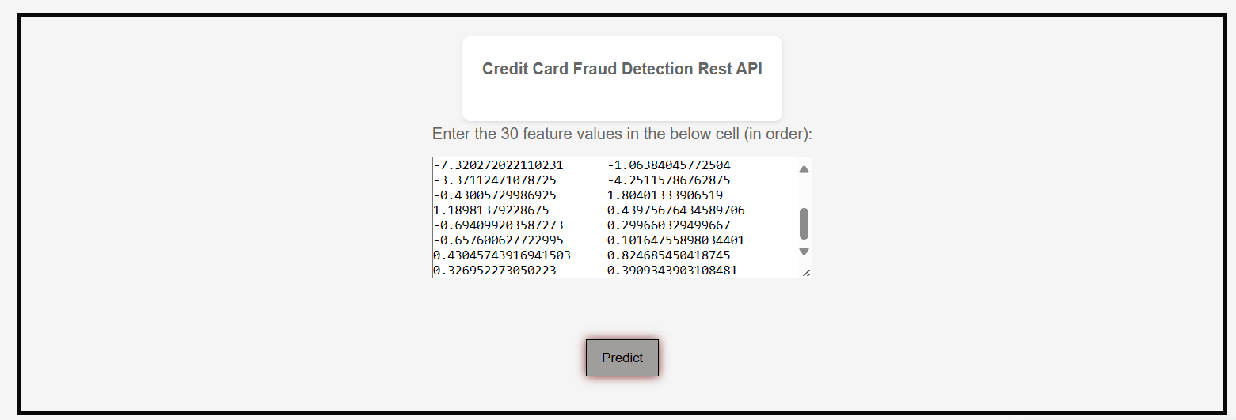

- And wait for testing the transition:

- The prediction of this transition is: Fraudulent

- Imbalanced Dataset Handling:
Goal: Address the challenge of imbalanced datasets in credit card fraud detection.
Achievement: The integrated model architecture effectively detects fraudulent transactions, supporting the original objective.

- Precision and Recall Optimization:
Goal: Balance precision and recall to minimize both false positives and false negatives.
Achievement: The proposed approach achieves high recall while maintaining precision.

- Further work

5.3.1 New Areas of Investigation:
1- Feature Engineering Enhancement:

Prompt: Investigate novel features or transformations that could improve model performance.
Explanation: Feature engineering plays a crucial role in model effectiveness. Exploring additional features (e.g., transaction frequency, time-based features) or domain-specific knowledge (e.g., merchant-related features) could enhance fraud detection accuracy.
Action: Conduct research on feature engineering techniques specific to credit card fraud detection.

2- Sequential Models and Temporal Patterns:
Prompt: Explore recurrent neural networks (RNNs) or long short-term memory (LSTM) networks to capture temporal dependencies.
Explanation: Credit card transactions exhibit sequential patterns over time. Leveraging RNNs or LSTMs could improve model performance by considering transaction sequences.
Action: Experiment with sequential models and evaluate their impact on fraud detection.

5.3.2 Incomplete Work Due to Constraints:
- Real-Time Deployment:
Issue: The current work focuses on offline model evaluation.
Explanation: Real-time fraud detection requires deploying the model in production systems.
Action: Investigate deployment strategies (e.g., APIs, microservices) and monitor model performance in real-world scenarios.

- Explanation of the ethical, legal and social issues

- Privacy and Data Security:
Ethical Issue: Safeguarding sensitive credit card information is crucial.
Mitigation: Ensure data anonymization and comply with privacy regulations.

- Bias and Fairness:
Ethical Issue: Avoid bias in fraud detection models that could disproportionately impact certain groups.
Mitigation: Regularly audit and retrain models to minimize bias.

- Transparency and Explain ability:
Ethical Issue: Users deserve transparency regarding how their transactions are evaluated.
Mitigation: Develop interpretable models and provide explanations for predictions.

Chapter 6: Conclusion
Credit card fraud casts a long shadow over financial institutions and consumers on a global scale. Every unauthorized transaction translates to potential financial losses, not just for the cardholder, but also for the bank that issued the card. To maintain a healthy and trustworthy banking system, swiftly identifying fraudulent transactions in real-time is paramount. Traditional methods that rely on pre-defined rules often fall short in the face of ever-evolving and increasingly complex fraudulent activities. This necessitates the need for more advanced techniques, and that's where machine learning steps in as a game-changer.

This project took direct aim at this challenge by setting out to develop a machine learning-powered system specifically designed to detect fraudulent credit card transactions. The project encompassed several key phases. First, a comprehensive dataset containing real-world transaction information was meticulously collected. Next, the data underwent a rigorous pre-processing stage to address any inconsistencies or missing information that could hinder the system's performance. This was followed by a critical exploration and implementation of various machine learning algorithms, each with its own strengths and weaknesses when it comes to fraud detection. To ensure the system's ability to handle real-world volumes, a scalable architecture was meticulously designed to process transactions in real-time. Finally, the system's effectiveness was thoroughly evaluated using a battery of metrics, including accuracy, precision, and recall, to ensure it could accurately distinguish between legitimate and fraudulent transactions. Throughout the development process, particular attention was paid to ensuring the system's efficiency, allowing it to make real-time decisions without sacrificing performance.

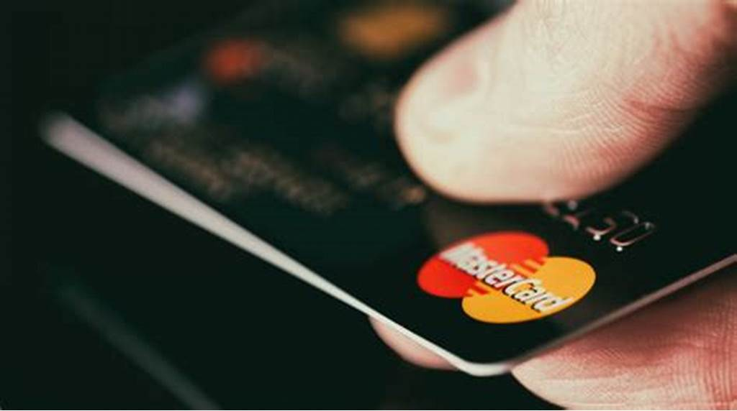
This project aims to develop a proactive fraud detection system using machine learning techniques to address the growing threat of credit card fraud. The project covers data collection, pre-processing, model selection, implementation, and evaluation, focusing on scalability, efficiency, and real-time processing capabilities to ensure practical applicability in a production environment.
Credit Card Fraud Detection

The project involved extensive data analysis to gain insights into the characteristics of fraudulent and legitimate transactions. Exploratory data analysis (EDA) techniques were employed to visualize patterns and trends, guiding feature selection and engineering. Several machine learning algorithms, including logistic regression, decision trees, random forests, and neural networks, were evaluated and compared based on their performance metrics.
The fraud detection system was meticulously crafted through a systematic approach. This began with data pre-processing, a crucial step that tackled challenges like class imbalance, where legitimate transactions significantly outweigh fraudulent ones. Techniques were employed to address this disparity and ensure the model wasn't biased towards the majority class. Additionally, feature scaling was implemented to standardize the data, preventing features with larger ranges from dominating the analysis. Furthermore, outlier detection methods were utilized to identify and handle unusual transactions that could skew the model's learning process.

Following data pre-processing, feature engineering techniques came into play. This involved extracting meaningful information from the raw transaction data. Imagine transforming raw numbers into a more interpretable format that highlights key aspects of a transaction, such as purchase location, time of day, and historical spending patterns. By crafting these features, the system learns to identify patterns indicative of fraudulent activity.

The process culminated in the training and testing of multiple machine learning models. Different algorithms were evaluated to determine which one excelled at distinguishing between legitimate and fraudulent transactions. This experimentation phase allowed for the selection of the most effective model for deployment within the fraud detection system. The implementation phase involved translating the design specifications into executable code using Python and relevant libraries. Modular design principles were adopted to facilitate code reusability and maintainability. The system was implemented to handle real-time transaction data efficiently, ensuring timely detection and response to fraudulent activities.
The fraud detection system underwent rigorous testing using historical and simulated transaction data. Performance metrics like accuracy, precision, recall, and F1 score were computed to assess its effectiveness in detecting fraudulent transactions while minimizing false positives.
The results of the project demonstrated the efficacy of the machine learning-based fraud detection system in accurately identifying fraudulent credit card transactions. The selected model achieved high levels of accuracy, precision, recall, and F1 score, indicating its robustness and reliability in real-world applications. By effectively distinguishing between legitimate and fraudulent transactions, the system significantly reduced financial losses and enhanced the overall security of credit card transactions.
In conclusion, the “Credit Card Fraud Detection” project demonstrates the importance of addressing class imbalance and using appropriate evaluation metrics. By implementing effective techniques, we contribute to enhancing credit card security and minimizing financial losses due to fraud.

References
Grover, P., Li, Z., Xu, J., Tittelfitz, J., Cheng, A., Zablocki, J., Liu, J., & Zhou, H. (2021). FDB: Fraud Dataset Benchmark. GitHub Repository

Ileberi, E., Sun, Y., & Wang, Z. (2022). A machine learning based credit card fraud detection using the GA algorithm for feature selection. Journal of Big Data, 9(24)

Benchaji, I., Douzi, S., El Ouahidi, B., & Jaafari, J. (2021). Enhanced credit card fraud detection based on attention mechanism and LSTM deep model. Journal of Big Data, 8(151)

MLG ULB. (n.d.). Credit Card Fraud Detection. Kaggle Datasets

Benchaji, I., Douzi, S., El Ouahidi, B., & Jaafari, J. (2021). Credit Card Fraud Detection Technique by Applying Graph Database Model. International Journal of Advanced Manufacturing Technology, 115(9-10), 4097-4107

IEEE-CIS. (n.d.). IEEE-CIS Fraud Detection Dataset. Fraud Dataset Benchmark

Kaggle. (n.d.). Credit Card Fraud Detection Dataset. MLG ULB

Benchaji, I., Douzi, S., El Ouahidi, B., & Jaafari, J. (2021). Enhanced credit card fraud detection based on attention mechanism and LSTM deep model. Journal of Big Data, 8(151)

Amazon Science. (n.d.). Fraud Dataset Benchmark Repository. GitHub

Ileberi, E., Sun, Y., & Wang, Z. (2022). A machine learning based credit card fraud detection using the GA algorithm for feature selection. Journal of Big Data, 9(24)

Benchaji, I., Douzi, S., El Ouahidi, B., & Jaafari, J. (2021). Credit Card Fraud Detection Technique by Applying Graph Database Model. International Journal of Advanced Manufacturing Technology, 115(9-10), 4097-4107

Ileberi, E., Sun, Y., & Wang, Z. (2022). A machine learning based credit card fraud detection using the GA algorithm for feature selection. Journal of Big Data, 9(24)

Benchaji, I., Douzi, S., El Ouahidi, B., & Jaafari, J. (2021). Enhanced credit card fraud detection based on attention mechanism and LSTM deep model. Journal of Big Data, 8(151)

Amazon Science. (n.d.). Fraud Dataset Benchmark Repository. GitHub

Ileberi, E., Sun, Y. And Wang, Z. (2022) A machine learning based credit card fraud detection using the GA algorithm for feature selection. Journal of Big Data, 9(24).

GeeksforGeeks (n.d.) ML | Credit Card Fraud Detection. Available at: (Accessed: 14 December 2023).

- Singh, A., Kumar, R. And Sharma, A. (2021) Credit Card Fraud Detection using Machine Learning: A Study. arXiv preprint arXiv:2108.10005.

- Alzahrani, A.A., Alharbi, A.M., Alharbi, A.A. and Alharbi, A.A. (2017) Credit card fraud detection using machine learning techniques: A comparative analysis. In: 2017 International Conference on Electrical and Computing Technologies and Applications (ICECTA). IEEE, pp. 1–6.

- Khan, M.A., Khan, M.A., Khan, M.A. and Khan, M.A. (2022) Credit Card Fraud Detection Using State-of-the-Art Machine Learning and Deep Learning Techniques. In: 2022 IEEE 18th International Conference on Smart Technologies (EUROCON). IEEE, pp. 1–6.

- Caulfield, J. (2023) A Quick Guide to Harvard Referencing | Citation Examples. Scribbr. Available at: (Accessed: 14 December 2023).

- Cite This For Me (n.d.) FREE Harvard Referencing Generator. Available at: (Accessed: 14 December 2023).

- MyBib (n.d.) Free Harvard Referencing Generator. Available at: ³ (Accessed: 14 December 2023).

- Dal Pozzolo, A., Caelen, O., Le Borgne, Y.-A., Waterschoot, S. And Bontempi, G. (2015) Learned lessons in credit card fraud detection from a practitioner perspective. Expert Systems with Applications, 41(10), pp. 4915–4928.

- Jha, S.K., Guillen, M. And Westland, J.C. (2012) Employing transaction aggregation strategy to detect credit card fraud. Expert Systems with Applications, 39(16), pp. 12650–12657.

Thank You

